Skip to main content

Global Knowledge

Top of Form

Bottom of Form

Screenshots

Lab 2: Configuring local storage

**Scenario**

Your manager has asked you to add disk space to a storage server that is running on a virtual machine. This virtual machine will potentially grow significantly in size in the upcoming months and you might need flexibility in your storage options. Your manager has asked you to optimize the cluster and sector size for virtual machines usage to accommodate large file sizes for storage on virtual machines. You need to assess the best options for storage and ease of expansion for potential future use.

Exercise 4 onwards repeats the first 3 exercises but instead leverages the Windows Admin Center to carry out the tasks.

Exercise 1: Creating and managing volumes

**Scenario**

In the test lab, you start by creating a number of volumes on the installed hard disks.

The main tasks for this exercise are as follows:

1. Create a hard disk volume and format for ReFS.
2. Create a mirrored volume.

Task 1: Create a hard disk volume and format for ReFS

1. Switch to [**LON-STOR1**](urn:gd:lg:a:select-vm) and send the [**CTRL+ALT+DEL**](urn:gd:lg:a:send-vm-key-combo) command and login as **[Adatum\AdatumAdmin](urn:gd:lg:a:send-vm-keys" \o "Paste text into VM)** with the password [**Pa55w.rd**](urn:gd:lg:a:send-vm-keys)
2. Right-click **Start**, and then click **Windows PowerShell (Admin)**.

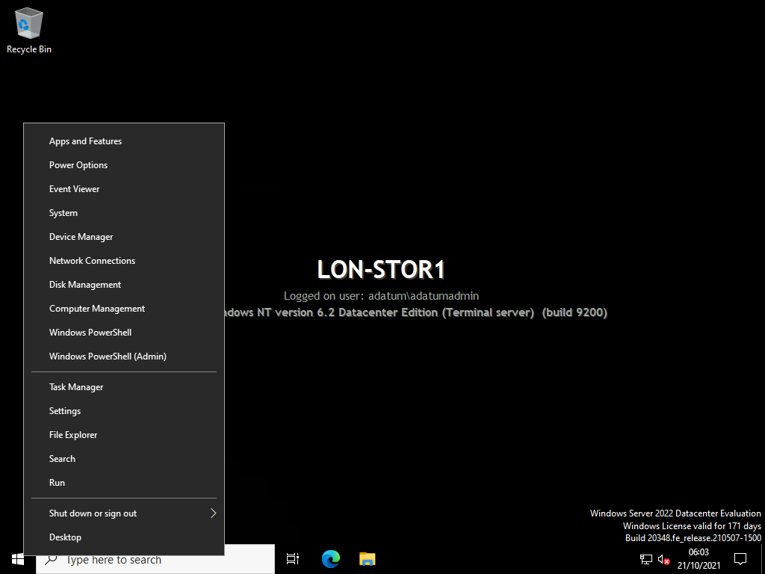

1. To list all the available disks that have yet to be initialized, at the Windows PowerShell command prompt, type the following command, and then press Enter:
2. Get-Disk | Where-Object PartitionStyle -Eq "RAW"

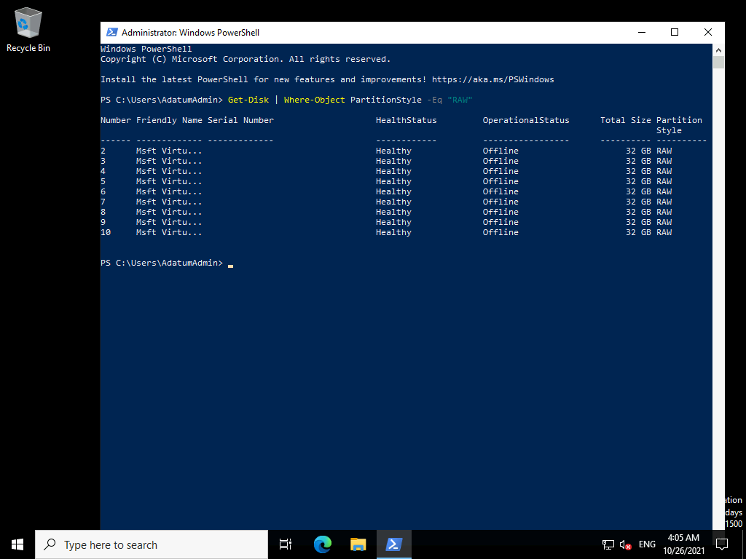

1. To initialize disk 2 at the Windows PowerShell command prompt, type the following command, and then press Enter:
2. Initialize-disk 2

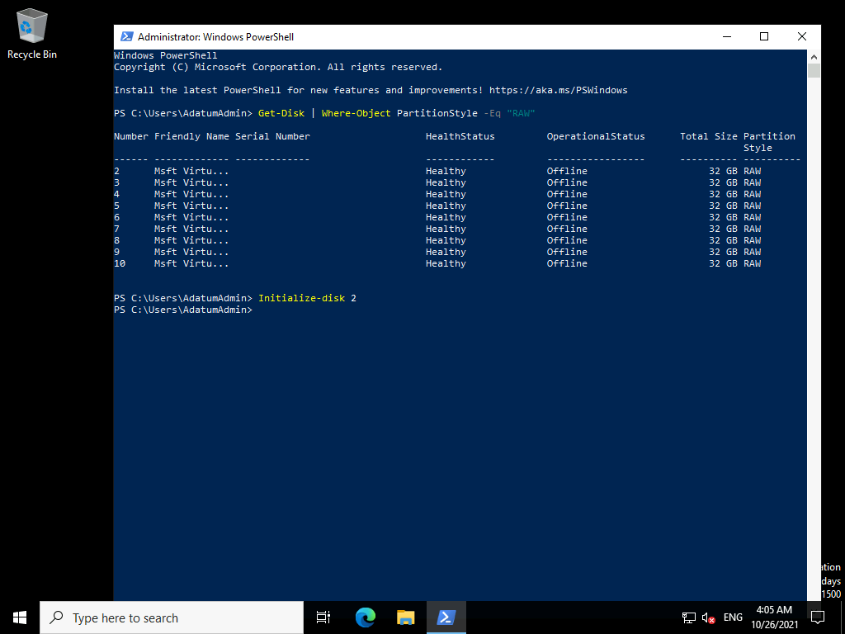

1. To review the partition table type, at the Windows PowerShell command prompt, type the following command, and then press Enter:
2. Get-disk

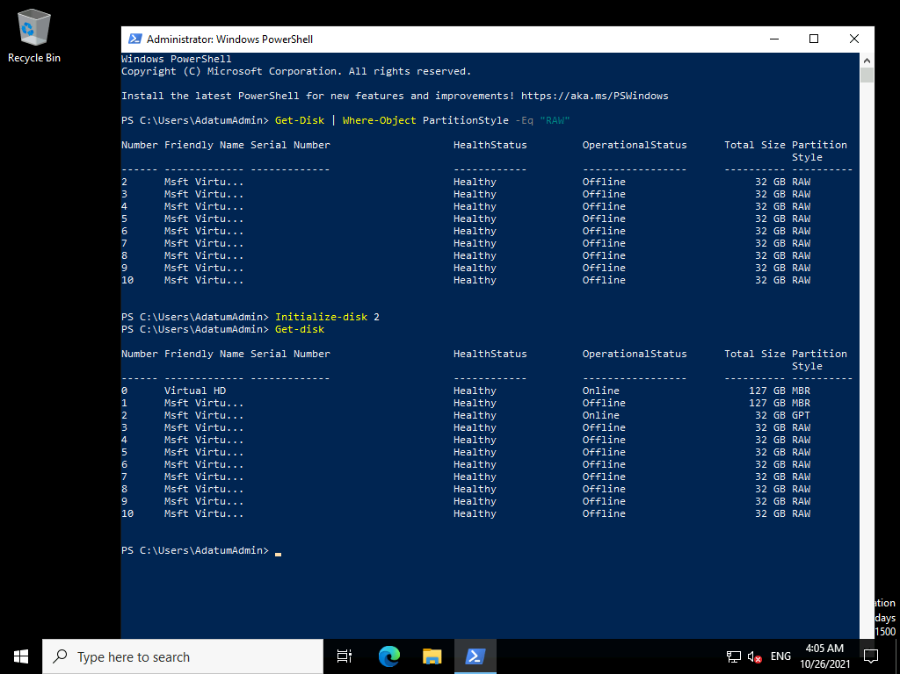

1. To create a Resilient File System (ReFS) volume by using all available space on disk 1, at the Windows PowerShell command prompt, type the following command, and then press Enter:
2. New-Partition -DiskNumber 2 -UseMaximumSize -AssignDriveLetter | Format-Volume -NewFileSystemLabel "Simple" -FileSystem ReFS

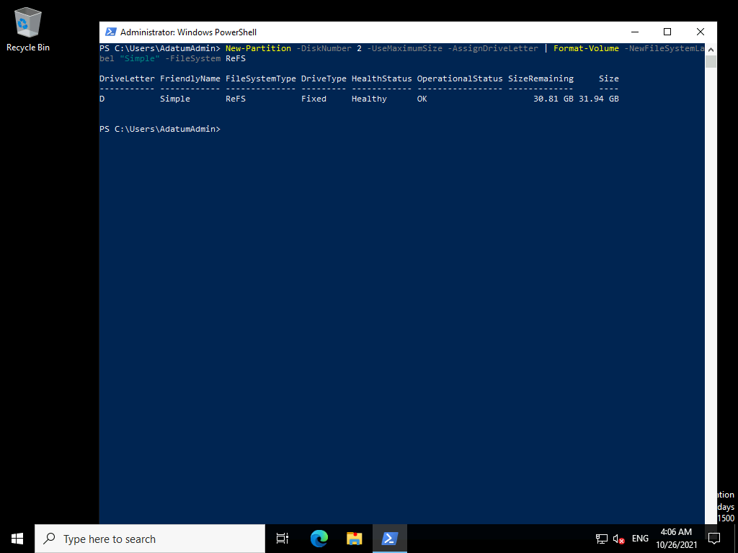

1. On the taskbar, click **File Explorer**.

**Note** If you receive the prompt **Do you want to format it?**, click **Cancel**.

1. If necessary select **This PC**.

**Question**: What drive letter has been assigned to the newly created volume?

**Answer**: Answers might vary, but it is assumed to be drive D as per the screenshot below.

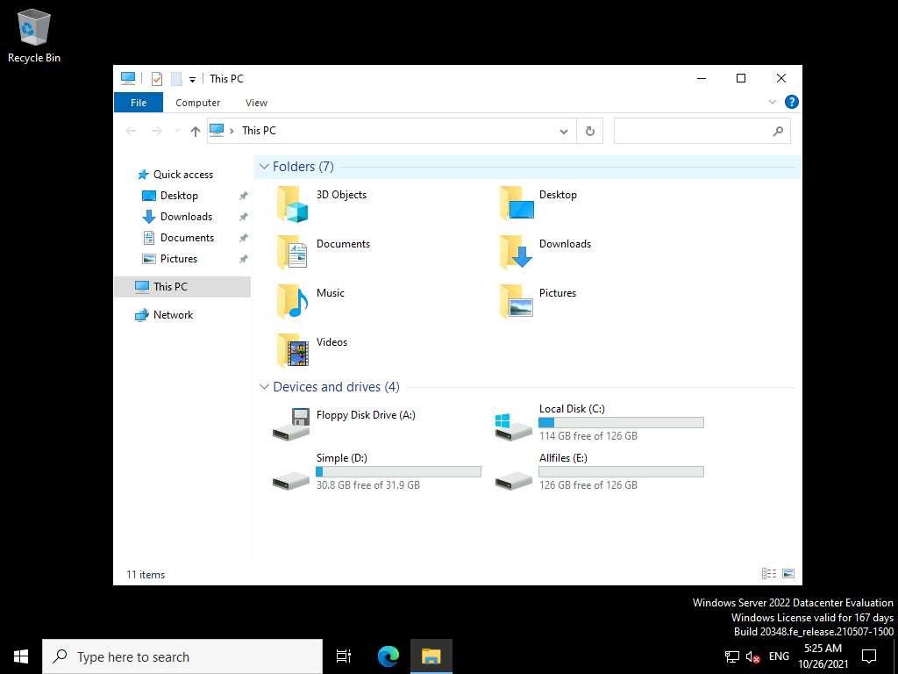

1. Close File Explorer.

Task 2: Create a mirrored volume

1. Right-click **Start**, and then click **Disk Management**.

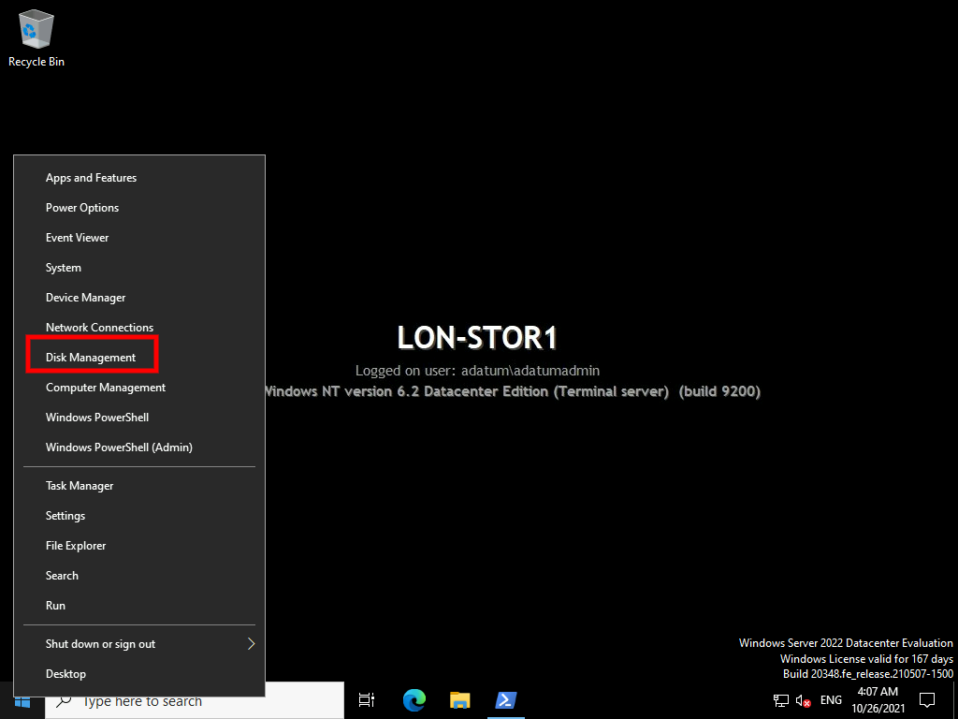

1. In the lower half of the display, scroll down and right-click **Disk 3**, and then click **Online**.

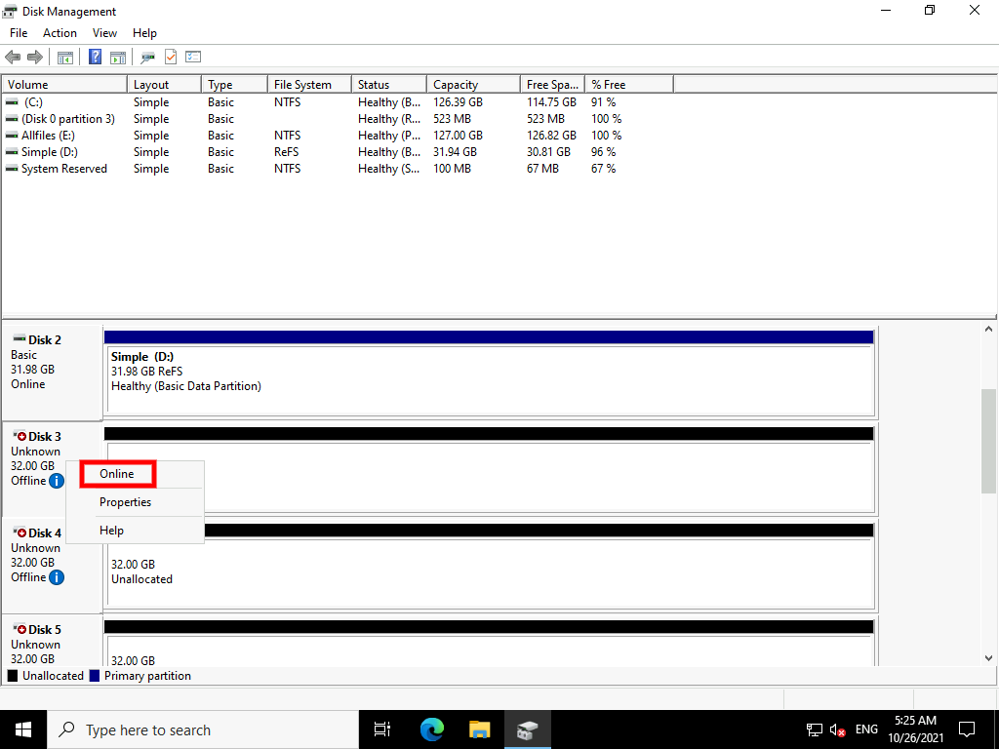

1. Repeat for **Disk 4**.
2. Close and reopen **Disk Management**.
3. In the **Initialize Disk** dialog box, click **OK** to initialize Disks 3 and 4.

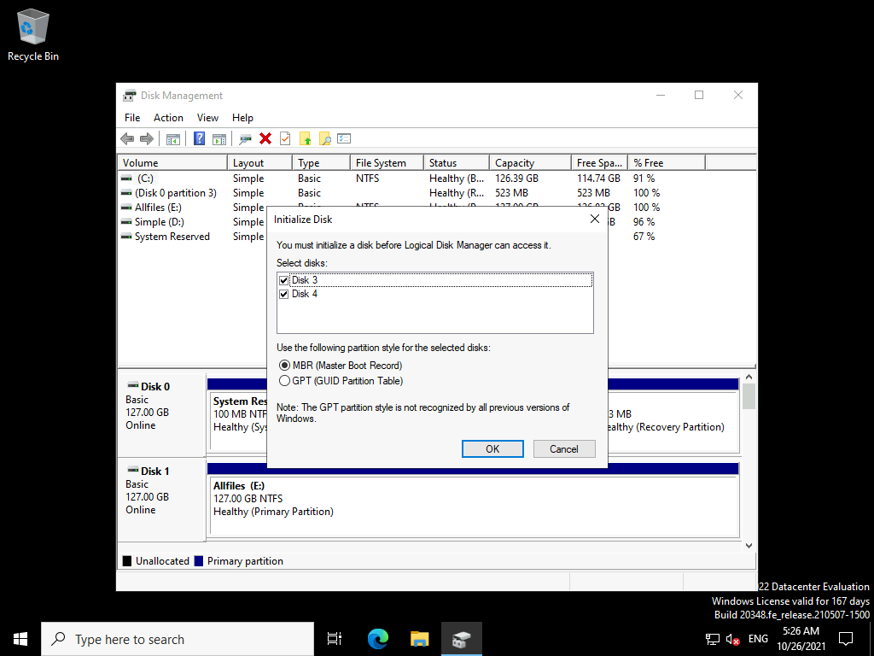

1. On Disk 3, right-click **Unallocated**, and then click **New Mirrored Volume**.

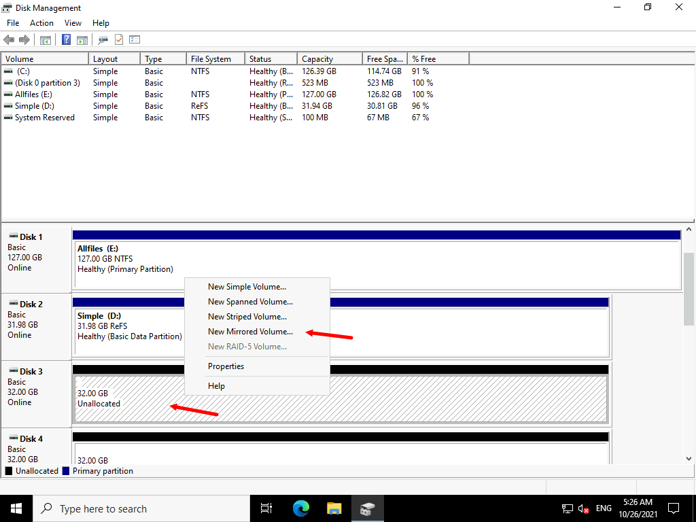

1. In the **New Mirrored Volume Wizard**, click **Next**.

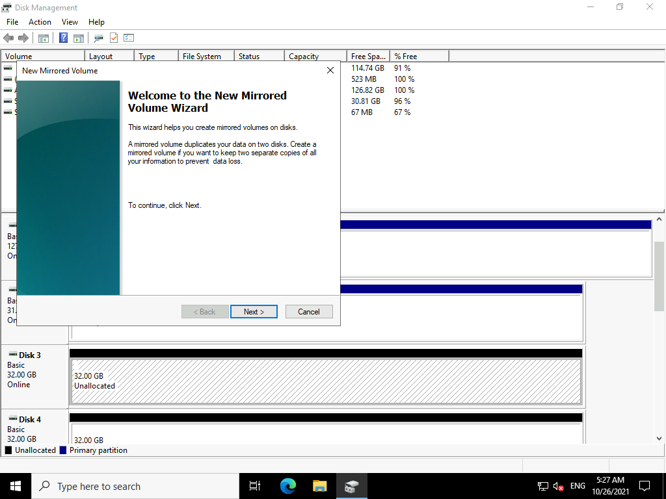

1. On the **Select Disks** page, in the available list, click **Disk 4**, and then click **Add**.

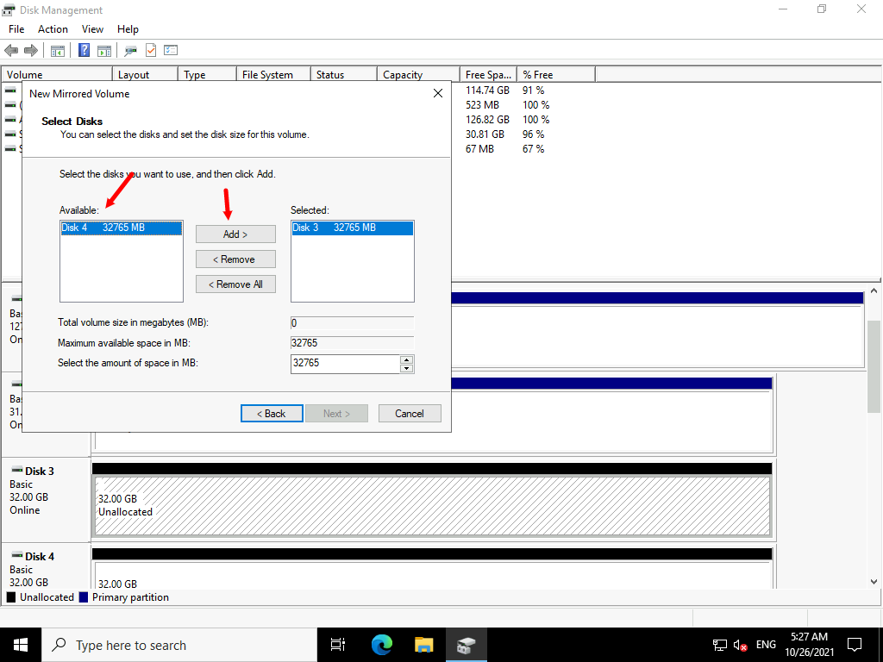

1. In the **Select the amount of space in MB** box, accept the default value, and then click **Next**.

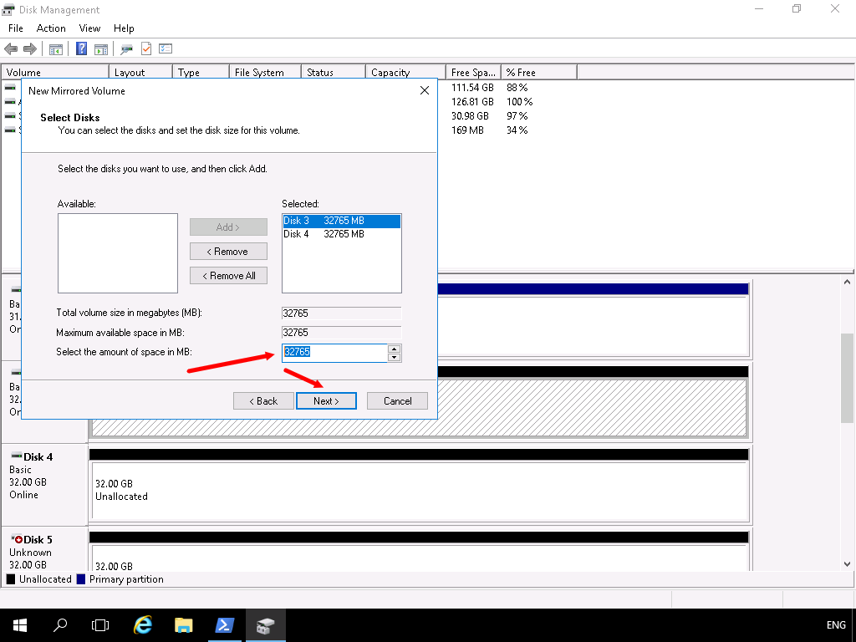

1. On the **Assign Drive Letter or Path** page, in the **Assign the following drive letter** box, click **M**, and then click **Next**.

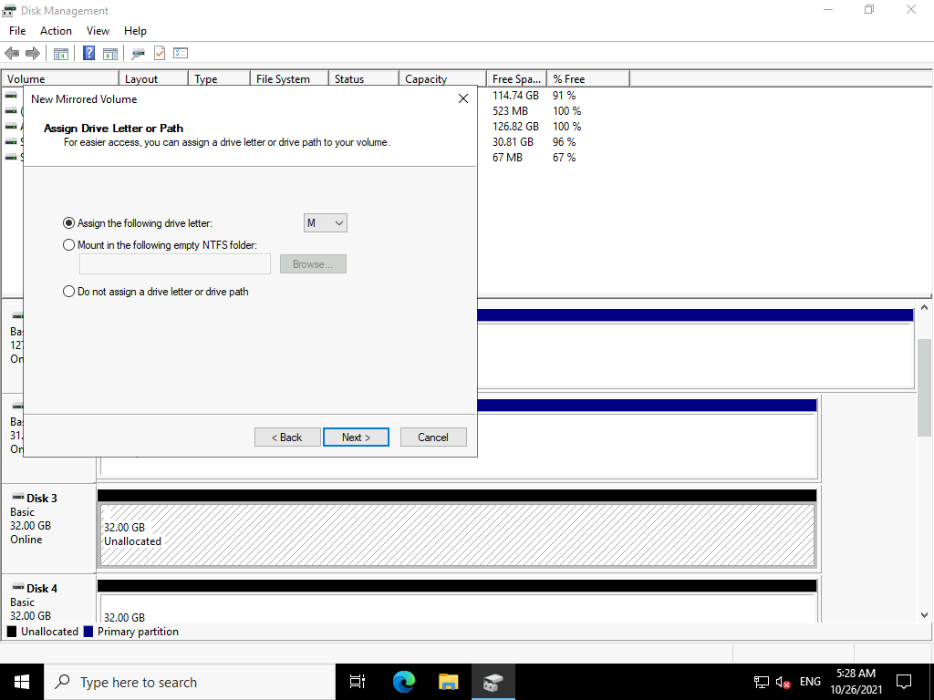

1. On the **Format Volume** page, in the **Volume label** text box, type [**MIRROR**](urn:gd:lg:a:send-vm-keys)

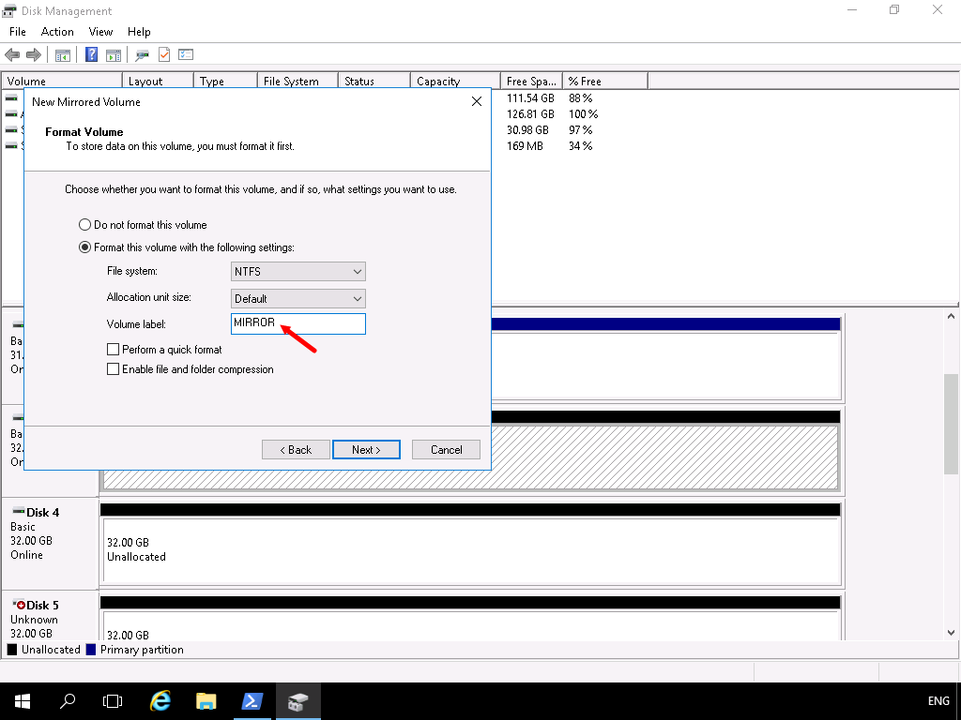

1. Select the **Perform a quick format** check box, and then click **Next**.

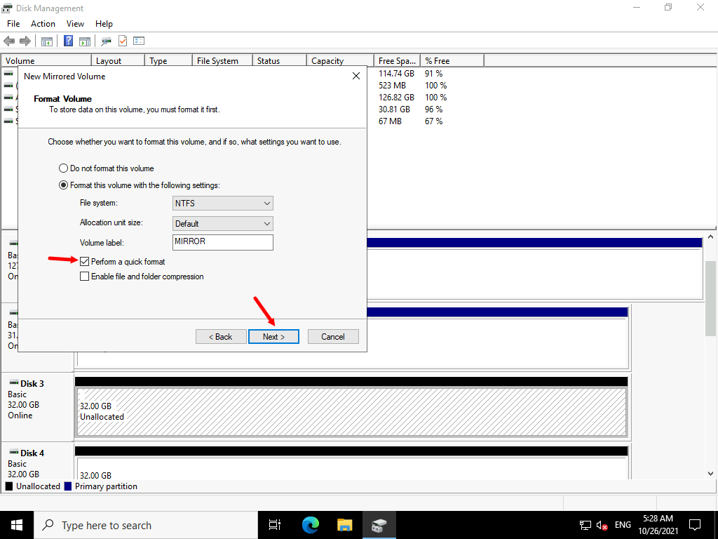

1. Click **Finish** to create your mirrored volume.

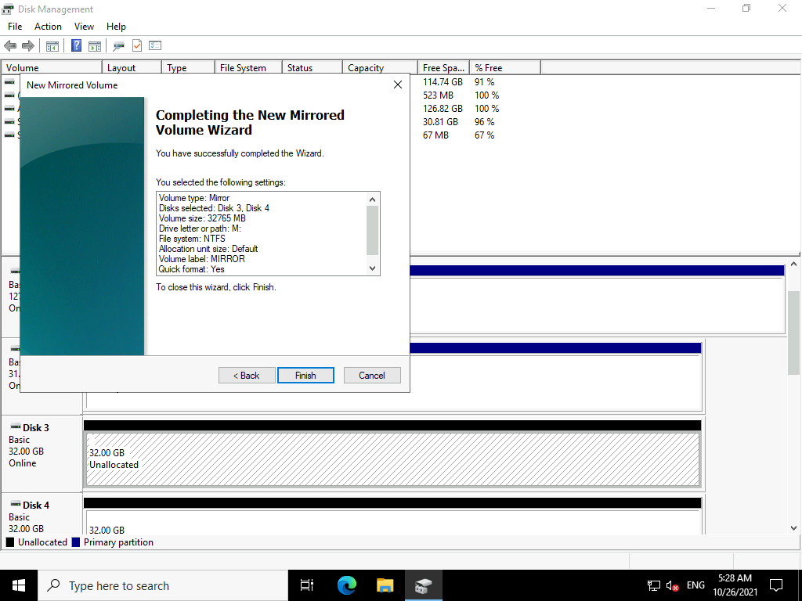

1. In the **Disk Management** dialog box, click **Yes** to convert both disks to dynamic disks.

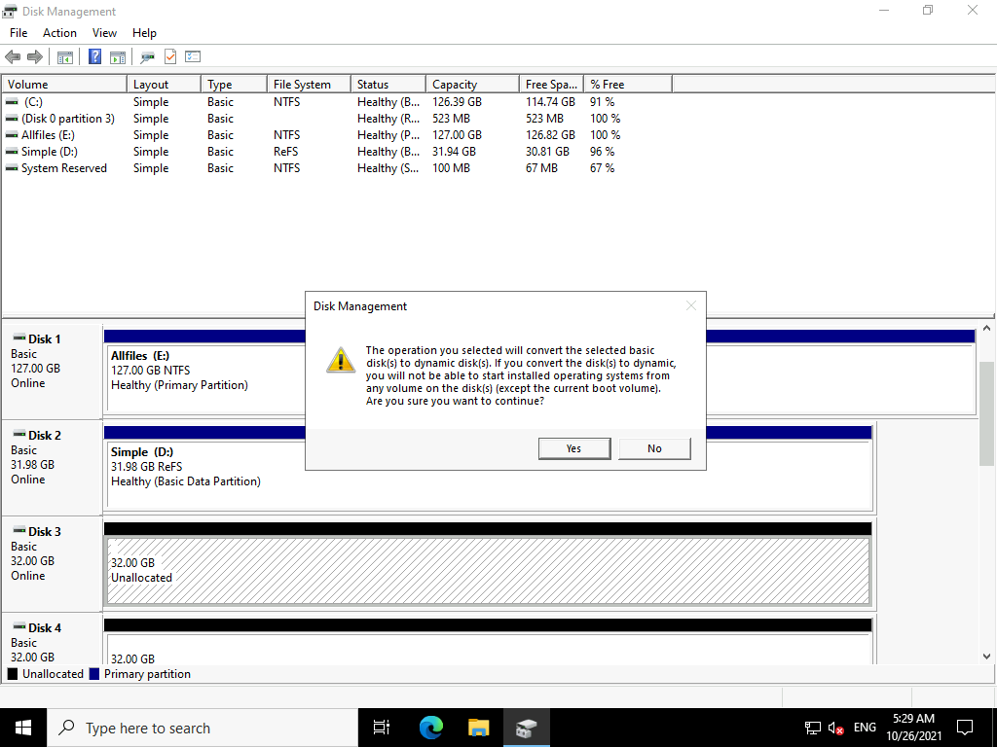

**Results**: After completing this exercise, you should have successfully created several volumes.

Exercise 2: Resizing volumes

**Scenario**

You create a new volume, and then realize that you must resize it. You decide to use Diskpart.exe to complete this process.

The main tasks for this exercise are as follows:

1. Create a simple volume and resize it.
2. Shrink a volume.

Task 1: Create a simple volume and resize it

1. Switch to **Windows PowerShell (Admin)**.

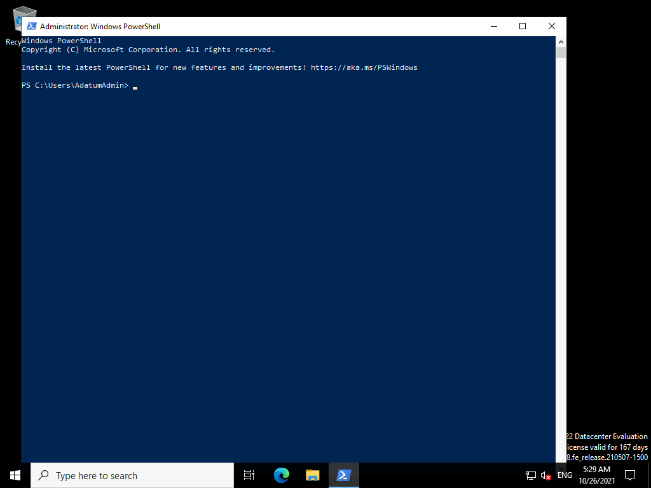

1. At the Windows PowerShell command prompt, type the following command, and then press Enter:
2. Initialize-disk 5

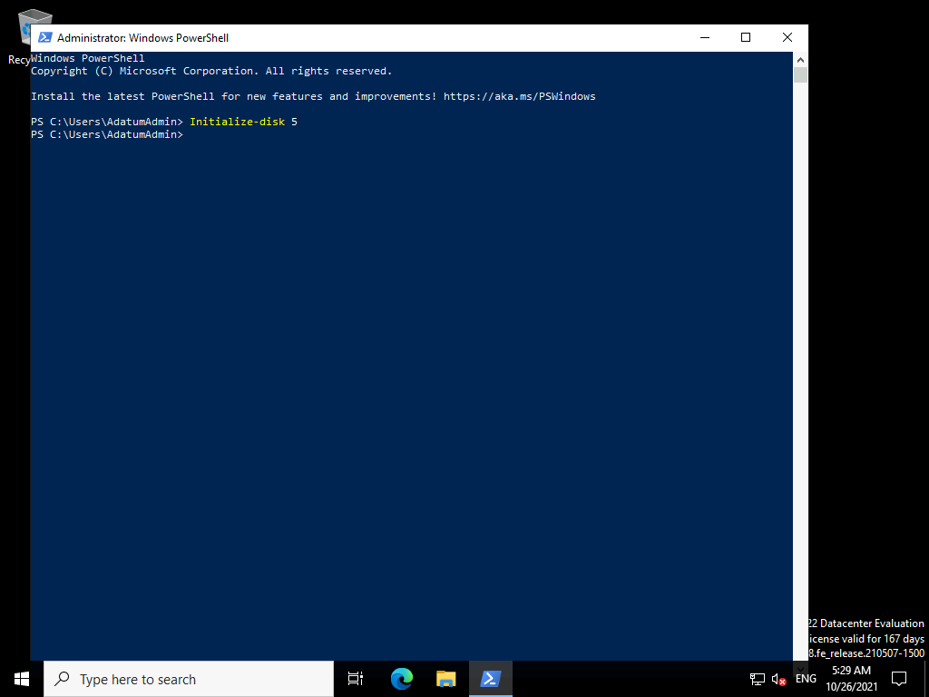

1. At the Windows PowerShell command prompt, type the following command, and then press Enter:
2. Diskpart

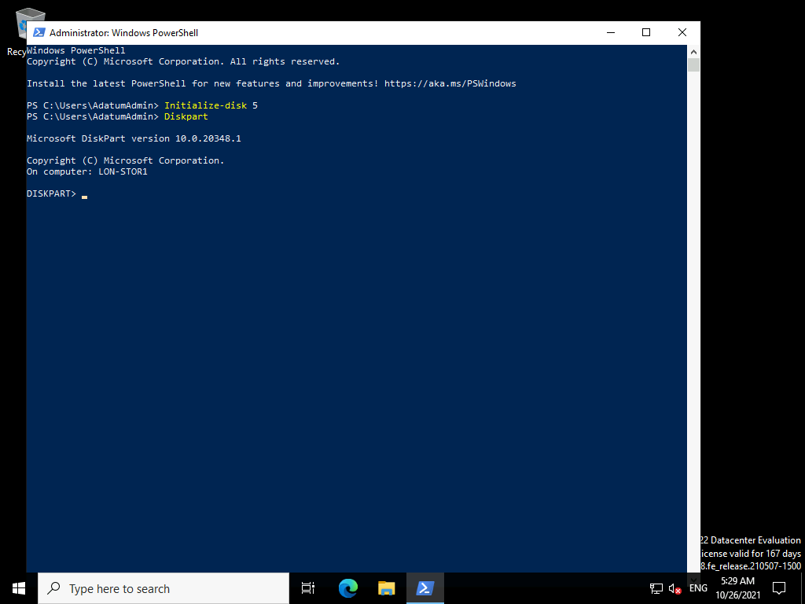

1. At the command prompt, type the following command, and then press Enter:
2. List disk

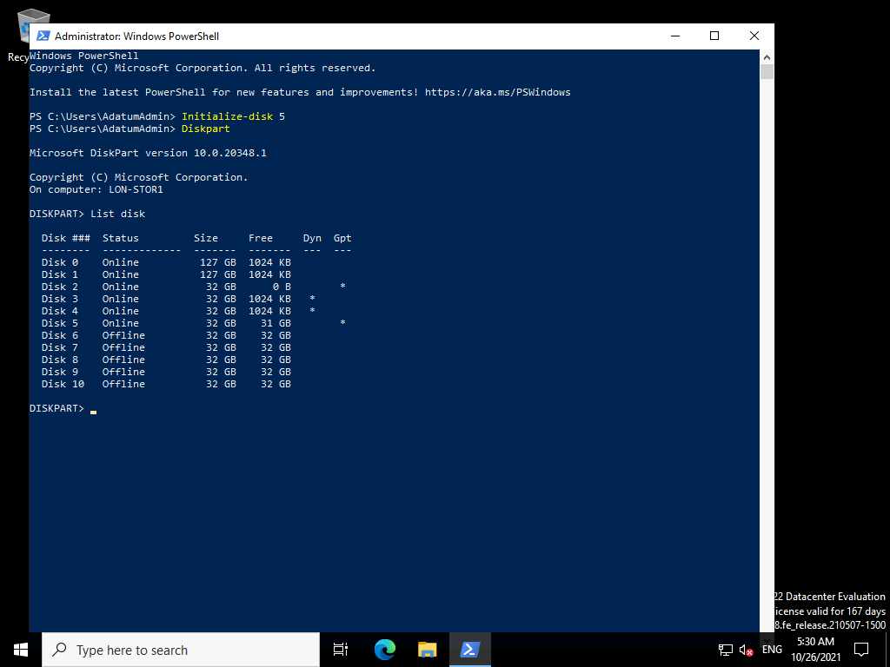

1. At the command prompt, type the following command, and then press Enter:
2. Select disk 5

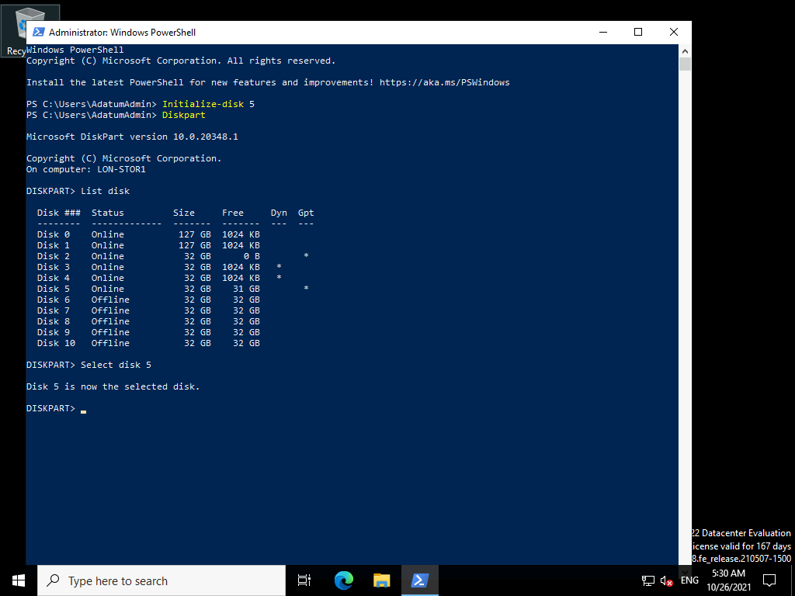

1. At the command prompt, type the following command, and then press Enter:
2. Convert dynamic

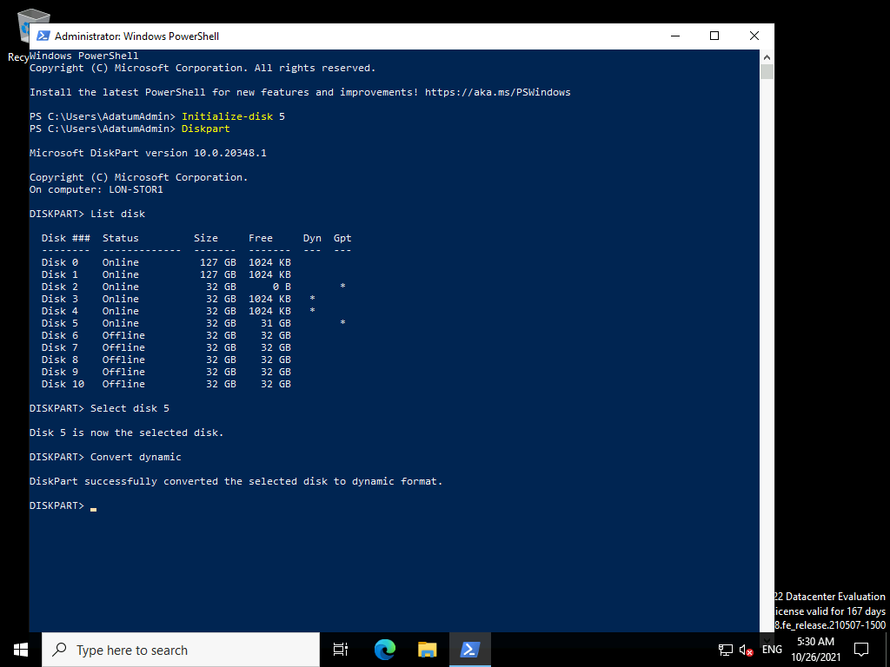

1. At the command prompt, type the following command, and then press Enter:
2. Create volume simple size=10000 disk=5

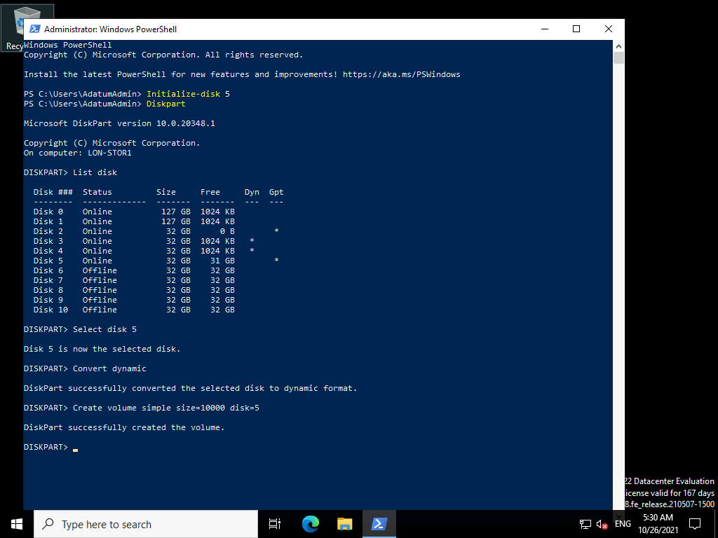

1. At the command prompt, type the following command, and then press Enter:
2. Assign letter=z

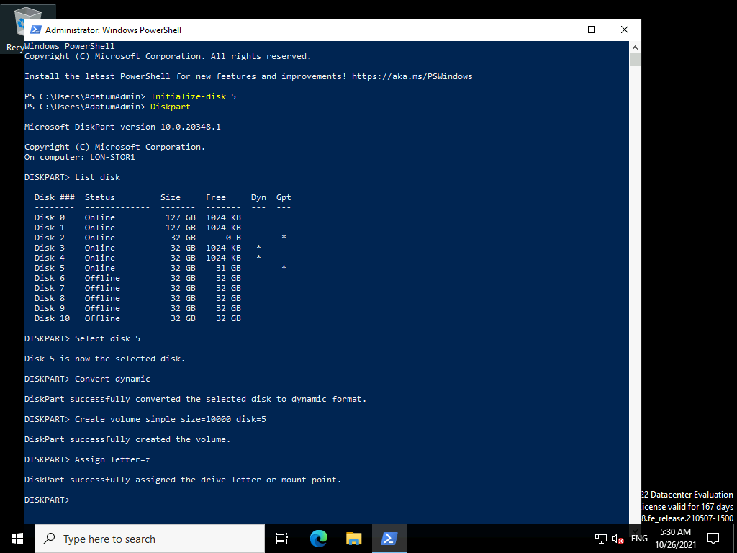

1. At the command prompt, type the following command, and then press Enter:
2. Format

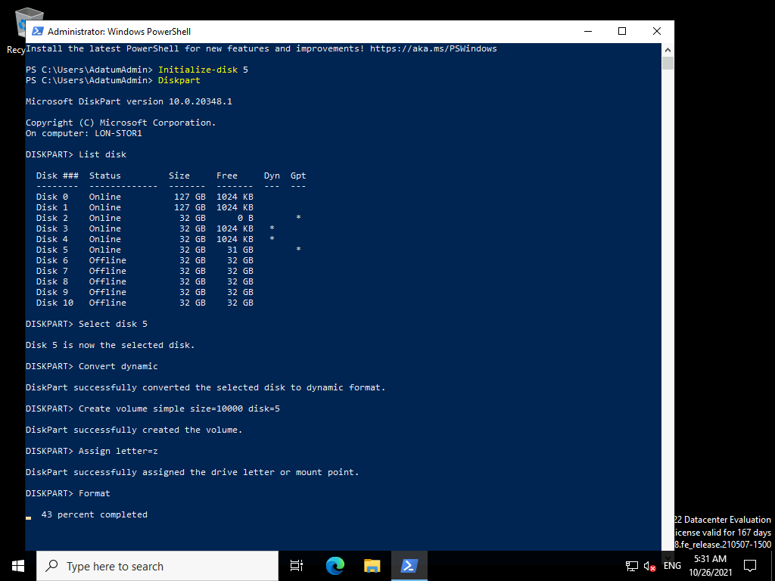

1. Switch to **Disk Management**. Verify the presence of an NTFS volume on **Disk 5** of size approximately **10** gigabytes (GB).
2. At the Windows PowerShell command prompt, type the following command, and then press Enter:
3. Extend size 10000

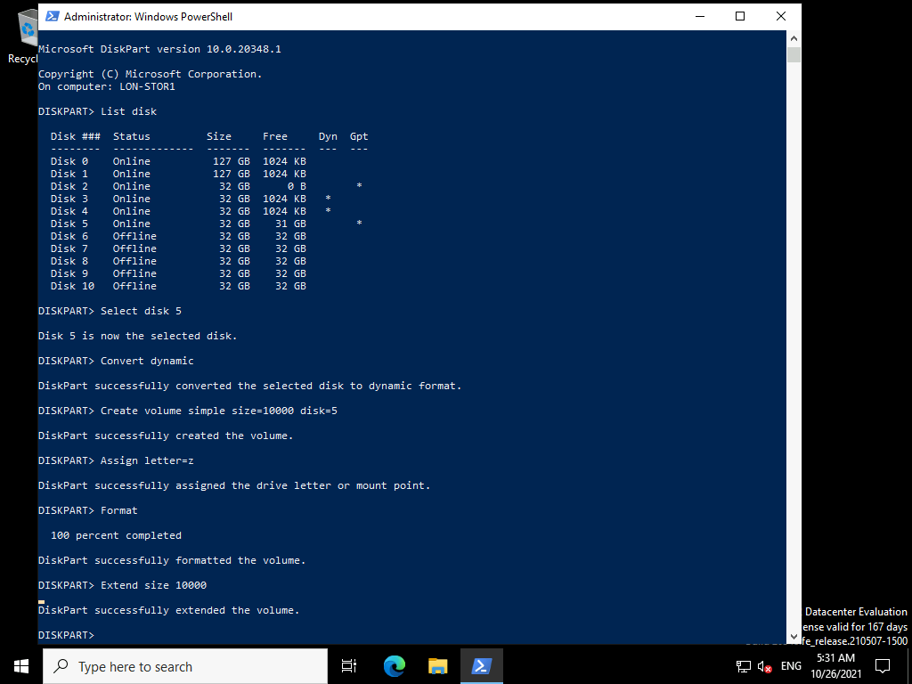

1. Switch to **Disk Management** which should still be open.
2. Verify the presence of an NTFS volume on **Disk 5** of size approximately **20** GB.

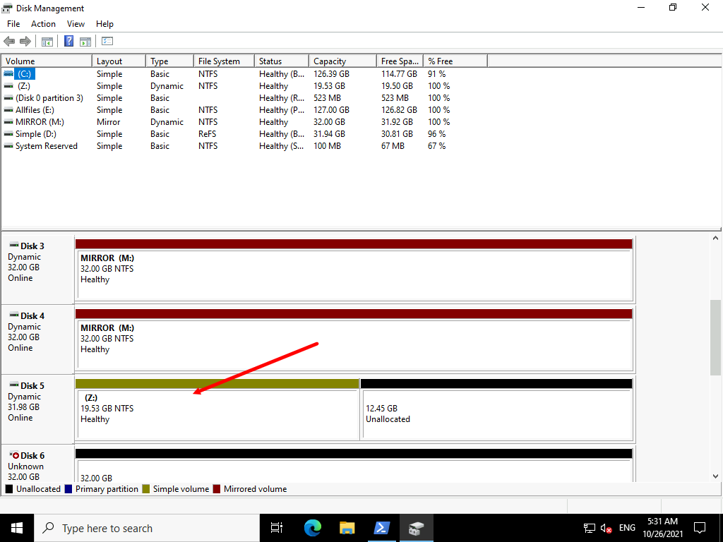

Task 2: Shrink a volume

1. Return to the Windows PowerShell command prompt, type the following command, and then press Enter:
2. Shrink desired=15000

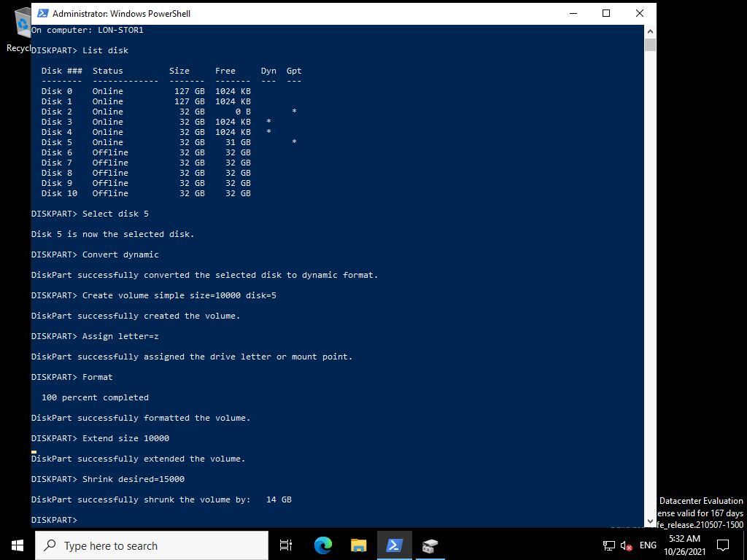

1. Switch to **Disk Management** which should still be open.
2. Verify the presence of an NTFS volume on **Disk 5** of size approximately **5** GB.

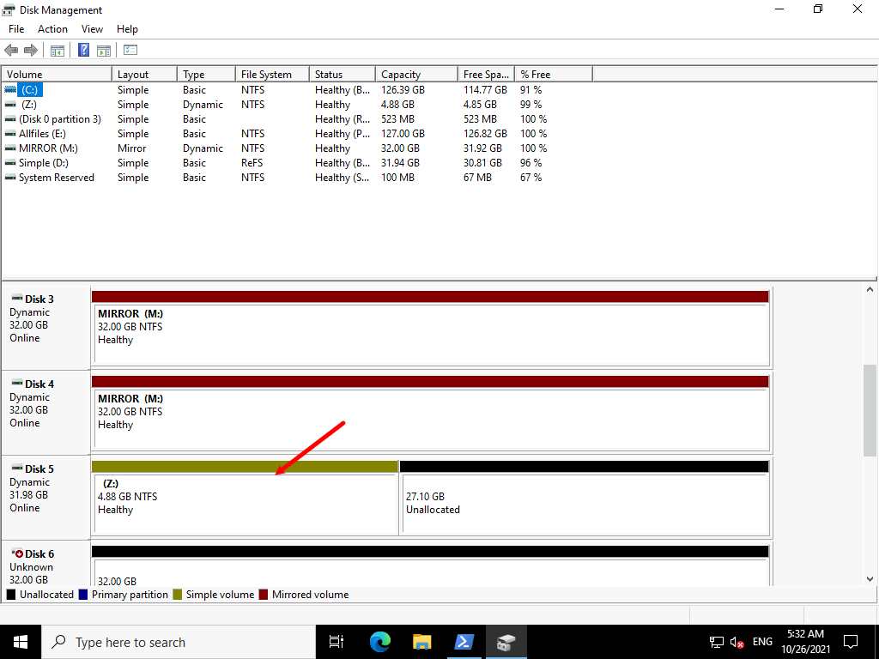

1. Close the **Windows PowerShell (Admin)** window.

**Results** : After completing this exercise, you should have successfully resized a volume.

Exercise 3: Managing virtual hard disks

**Scenario**

You are required to create and configure virtual hard disks for use in a Windows Server 2016 server computer. The virtual hard disk is for the Sales department. You decide to use Windows PowerShell to achieve these objectives. First, you must install the Windows PowerShell Hyper-V module.

The main tasks for this exercise are as follows:

1. Install the Hyper-V module.
2. Create a virtual hard disk.
3. Reconfigure the virtual hard disk.

Task 1: Install the Hyper-V module

1. Switch to [**LON-HV2**](urn:gd:lg:a:select-vm) and send the [**CTRL+ALT+DEL**](urn:gd:lg:a:send-vm-key-combo) command. Log on as **[Adatum\AdatumAdmin](urn:gd:lg:a:send-vm-keys" \o "Paste text into VM)** and the password [**Pa55w.rd**](urn:gd:lg:a:send-vm-keys)

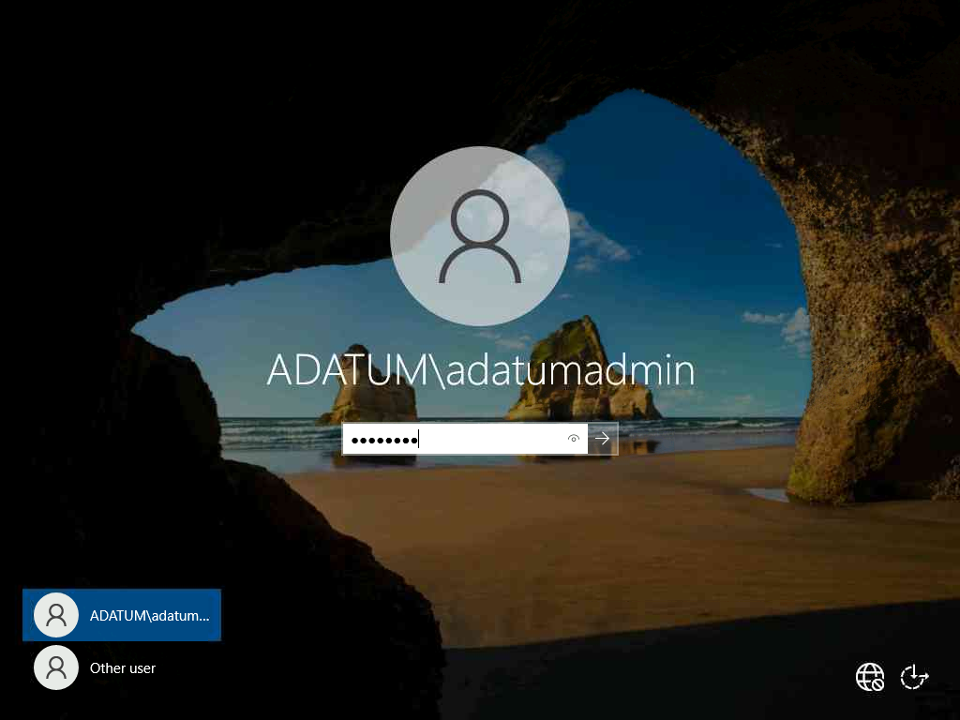

1. Click **Start**, and then click **Server Manager**.

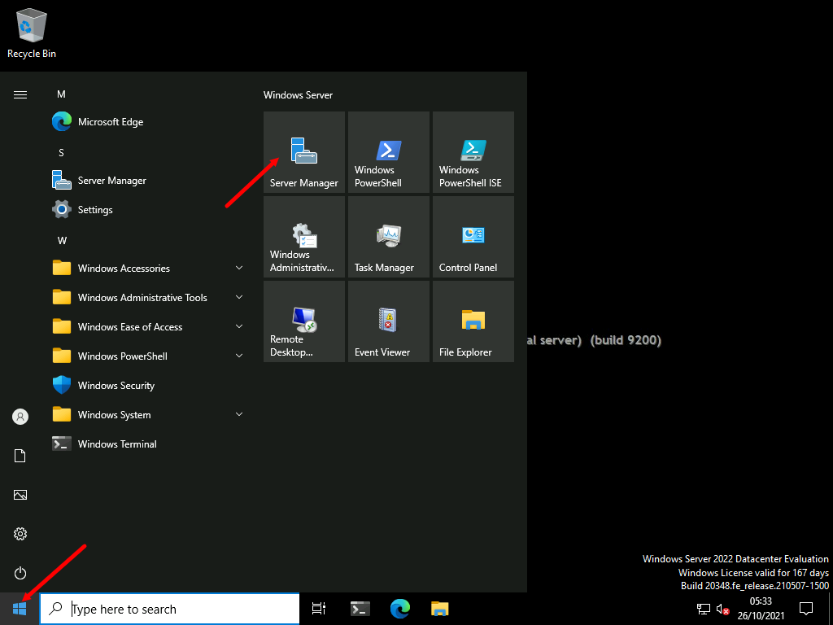

1. In Server Manager, click **Manage**, then click **Add roles and features**.

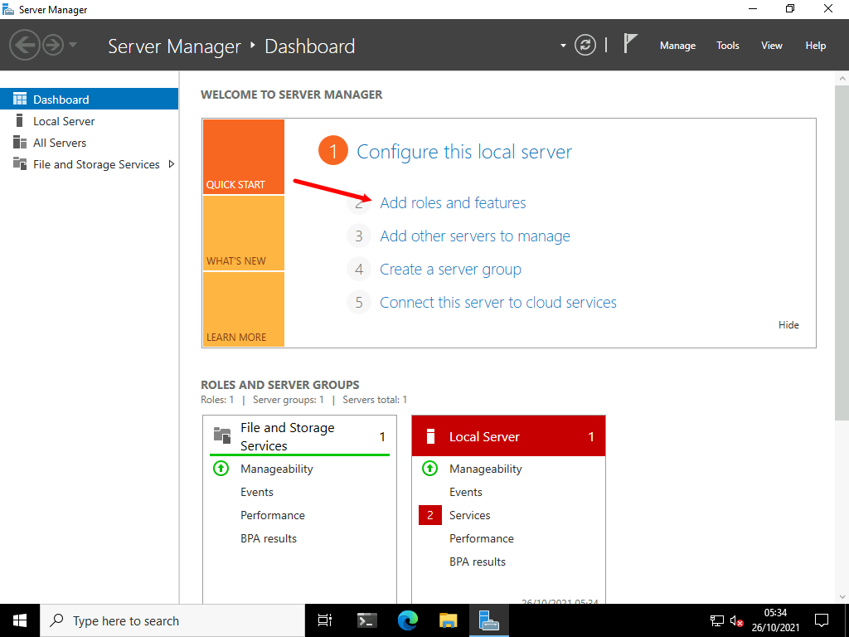

1. In the **Add Roles and Features Wizard**, on the **Before you begin** page, click **Next**.

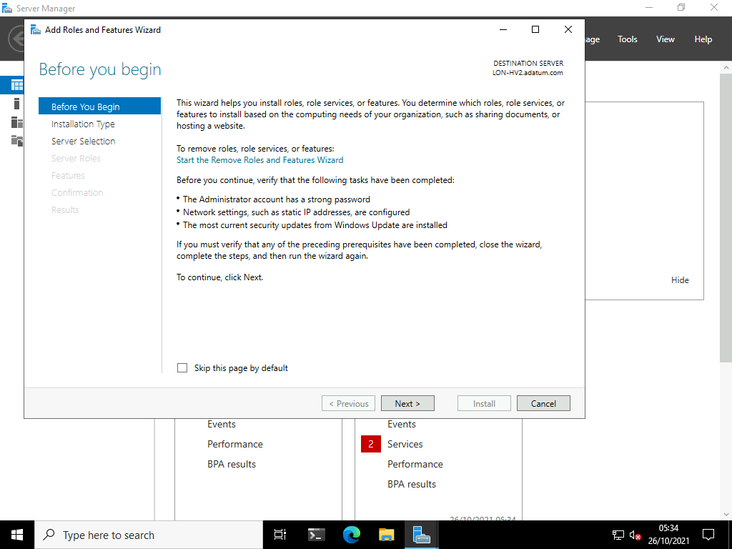

1. On the **Select installation type** page, click **Next**.

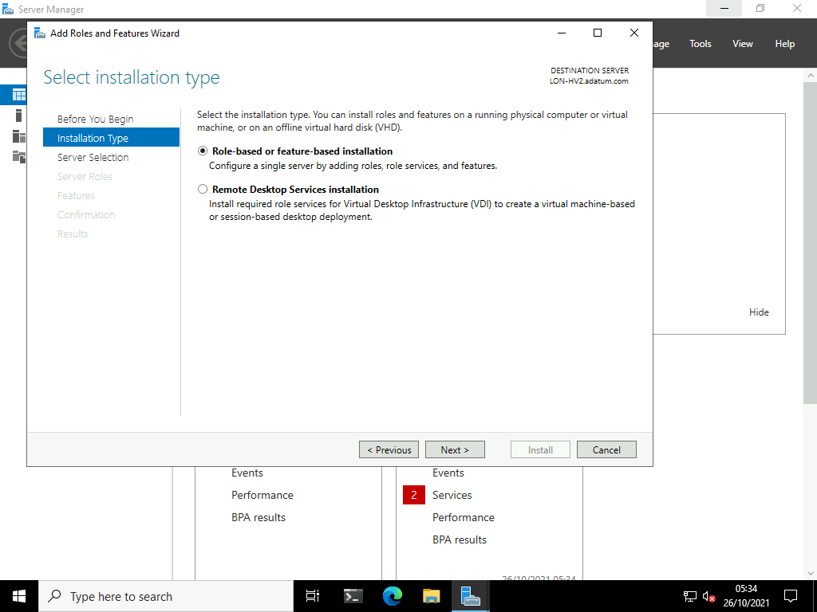

1. On the **Select destination server** page, click **Next**.

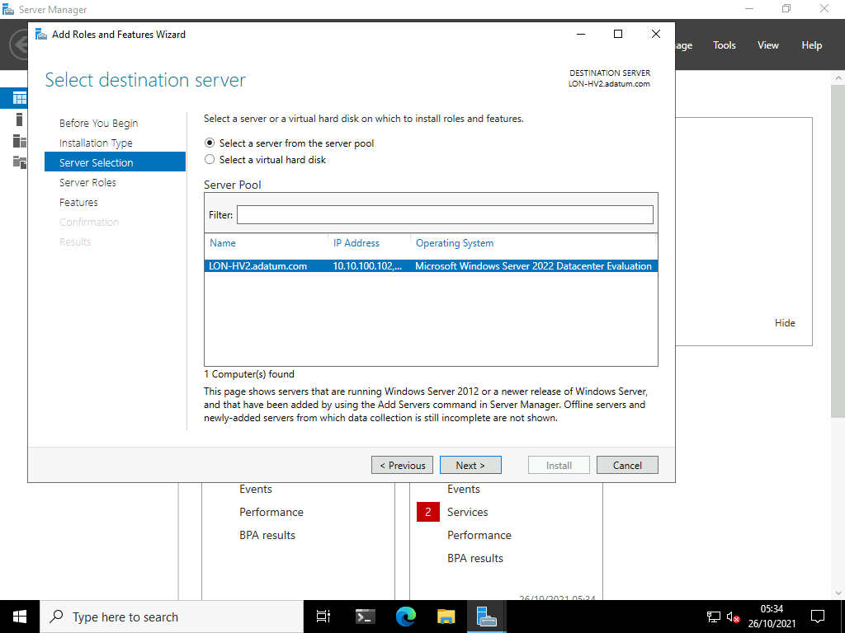

1. On the **Select server roles** page, select the **Hyper-V** check box, click **Add Features**, and then click **Next**.

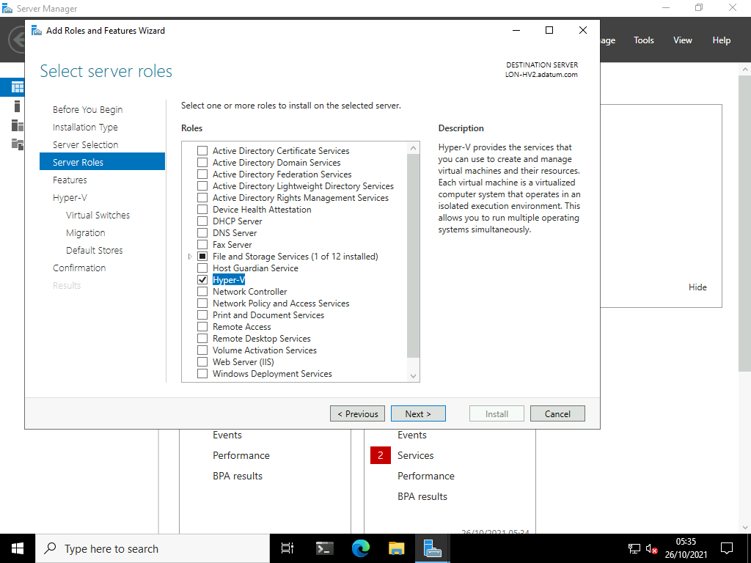

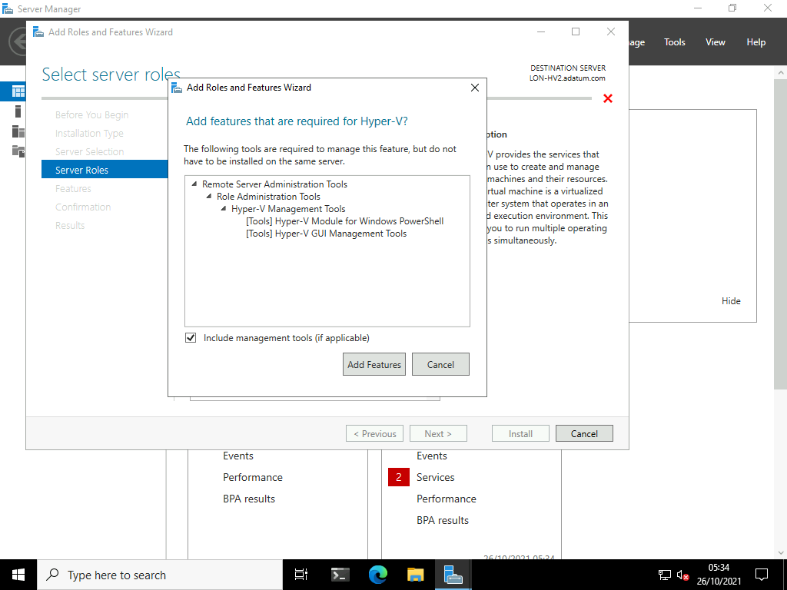

1. On the **Select features** page, click **Next**.

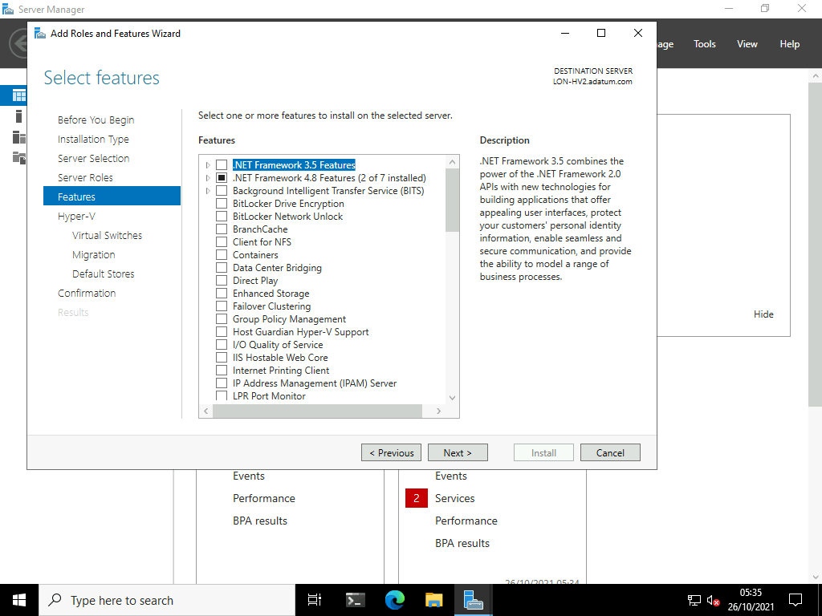

1. On the **Hyper-V** page, click **Next**.

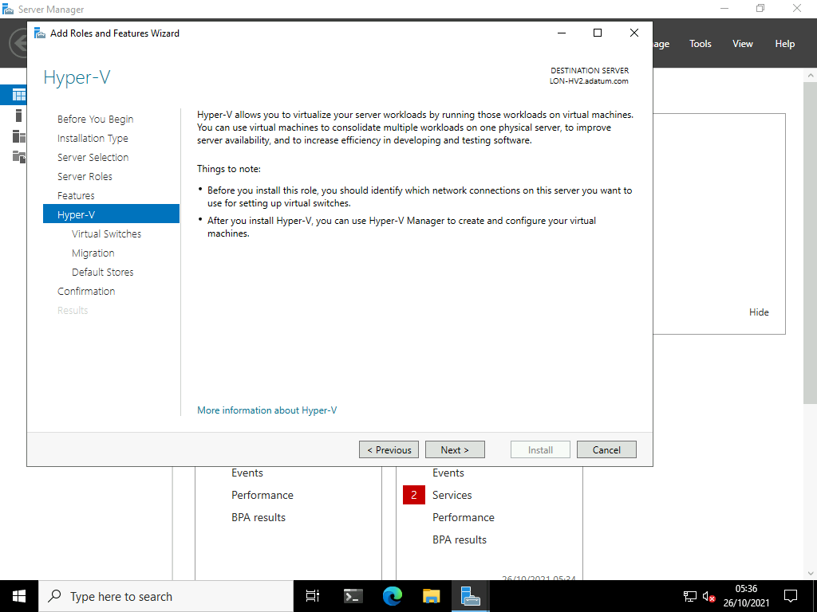

1. On the **Create Virtual Switches** page, click **Next**.

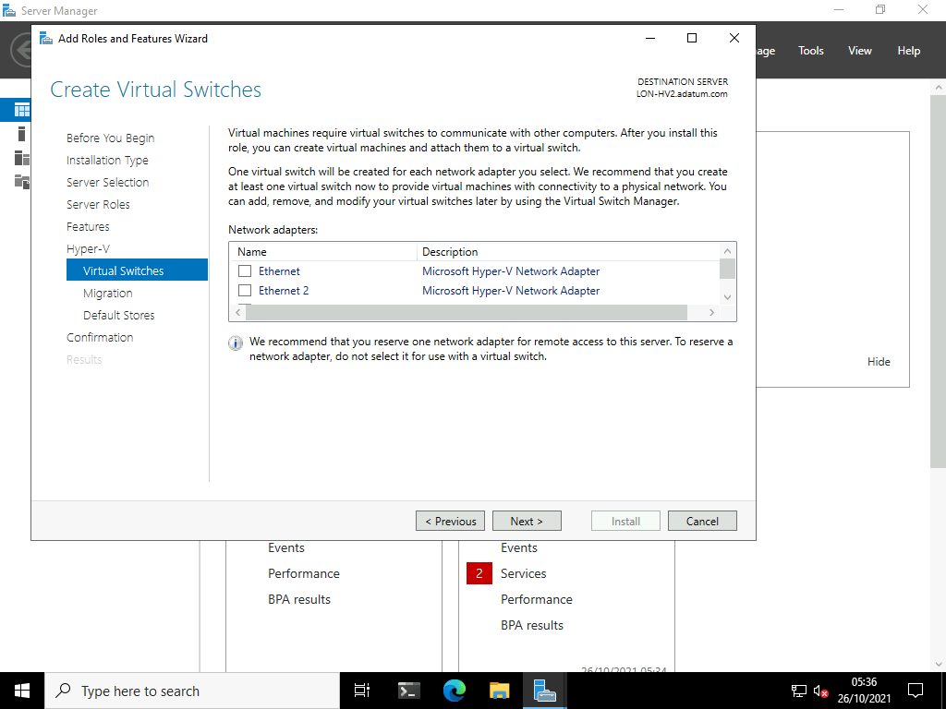

1. On the **Virtual Machine Migration** page, click **Next**.

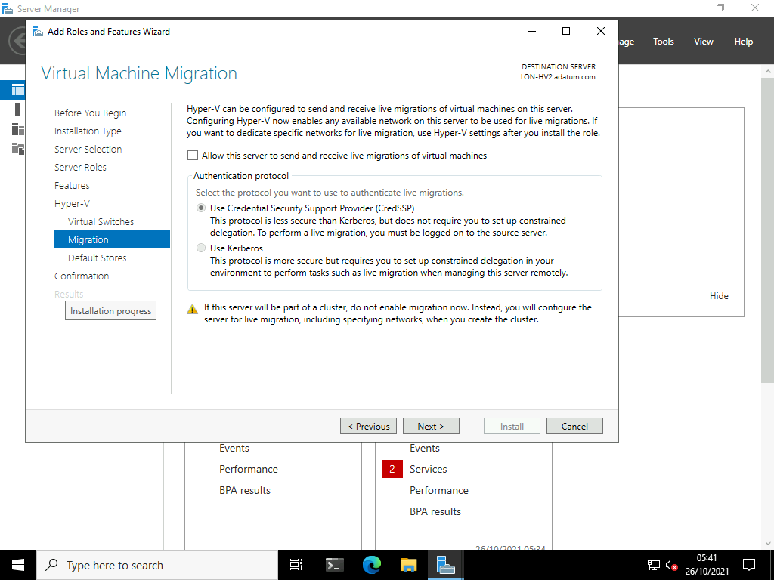

1. On the **Default Stores** page, click **Next**.

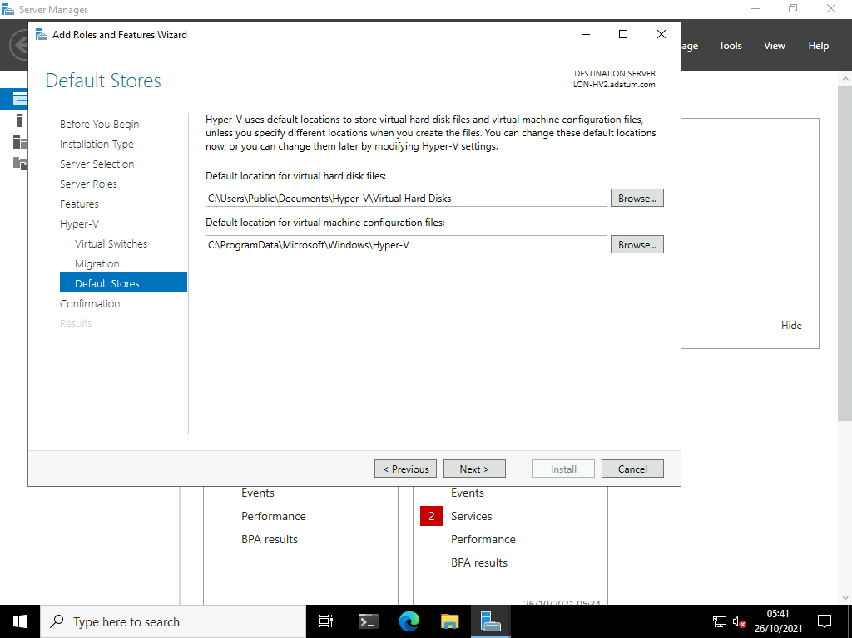

1. On the **Confirm installation selections** page, select **Restart the destination server automatically if required**, click **Yes**, and then click **Install**.

**Note:** Your computer will restart twice following installation of the Hyper-V components.

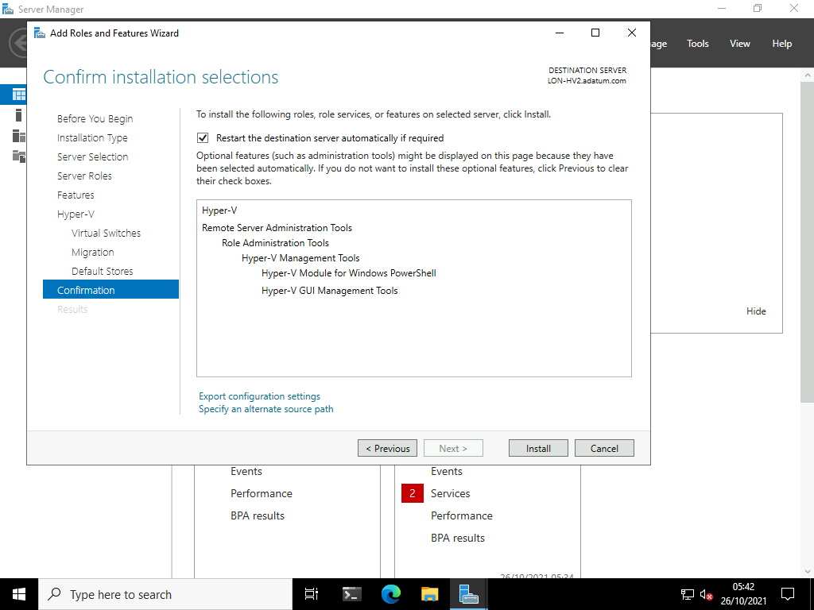

1. Once rebooted, send the [**CTRL+ALT+DEL**](urn:gd:lg:a:send-vm-key-combo) command. Log on as **[Adatum\AdatumAdmin](urn:gd:lg:a:send-vm-keys" \o "Paste text into VM)** and the password [**Pa55w.rd**](urn:gd:lg:a:send-vm-keys)

Task 2: Create a virtual hard disk

1. Right-click **Start**, and select **Windows PowerShell (Admin)**

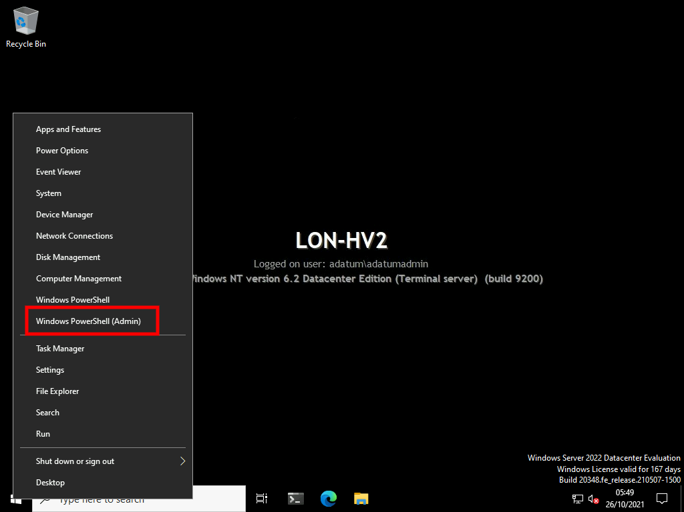

1. At the Windows PowerShell command prompt, type the following command, and then press Enter:
2. New-VHD -Path c:\sales.vhd -Dynamic -SizeBytes 10Gb | Mount-VHD -Passthru | Initialize-Disk -Passthru | New-Partition -AssignDriveLetter -UseMaximumSize | Format-Volume -FileSystem NTFS -Confirm:$false -Force

**Note** If you receive the prompt **Do you want to format it?**, click **Cancel**.

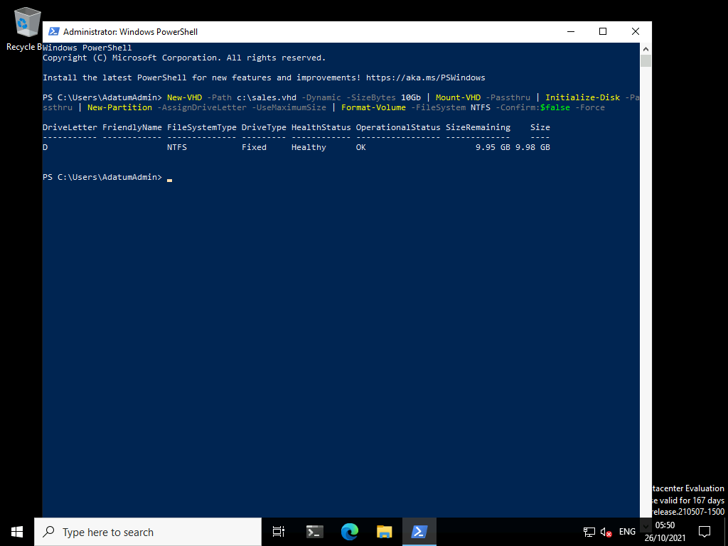

Task 3: Reconfigure the virtual hard disk

1. To dismount the virtual hard disk, at the Windows PowerShell command prompt, type the following command, and then press Enter:
2. Dismount-vhd C:\Sales.vhd

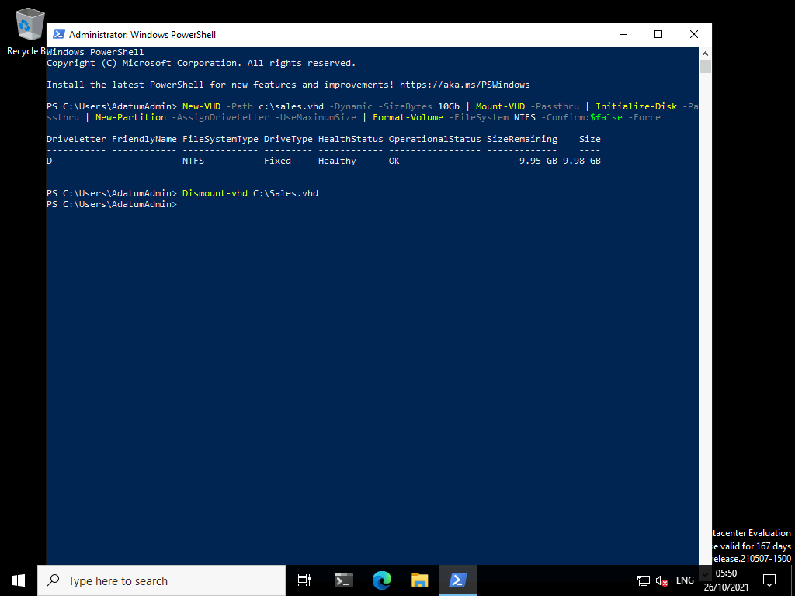

1. To check the properties of the virtual hard disk, at the **Windows PowerShell** command prompt, type the following command, and then press Enter:
2. Get-vhd C:\Sales.vhd

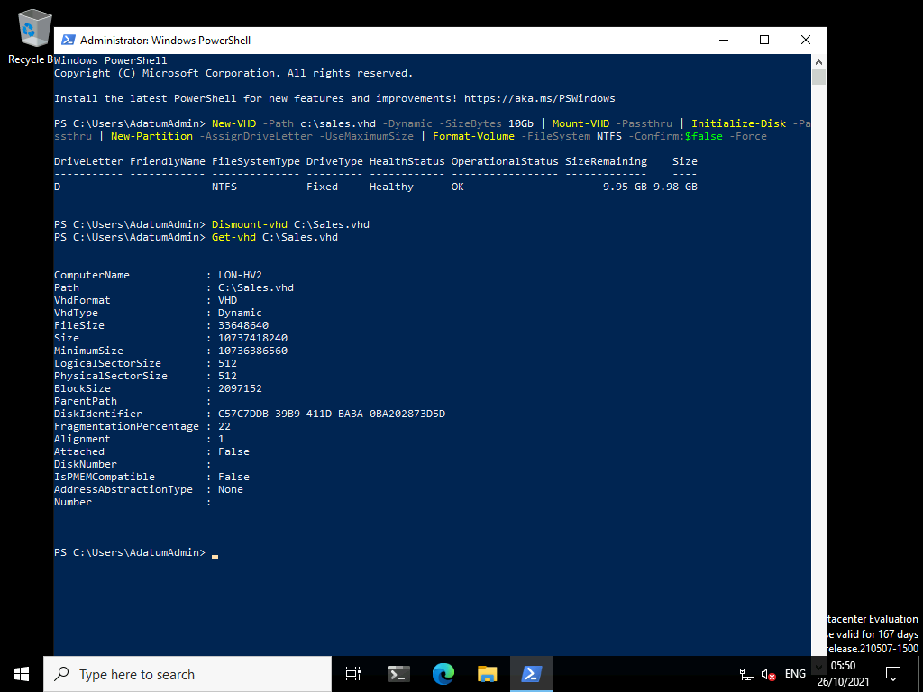

**Question** :What is the physical sector size?

**Answer** : Answers may vary, but it is likely to be 512.

1. To convert to a .vhdx file, at the Windows PowerShell command prompt, type the following command, and then press Enter:
2. Convert-VHD -Path C:\Sales.vhd -DestinationPath c:\Sales.vhdx

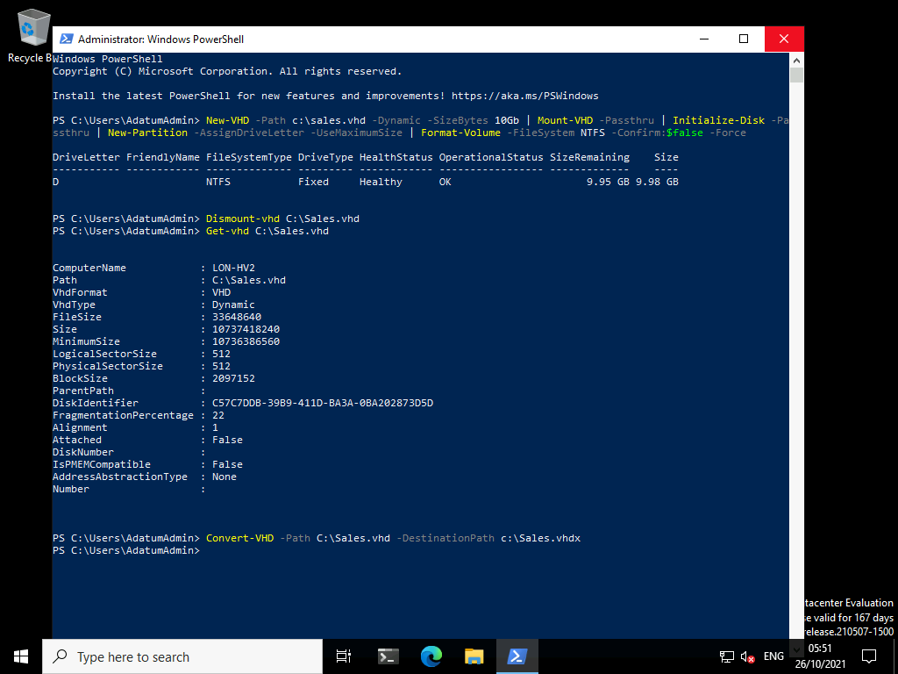

1. To change the sector size, at the Windows PowerShell command prompt, type the following command, and then press Enter:
2. Set-VHD -Path c:\Sales.vhdx -PhysicalSectorSizeBytes 4096

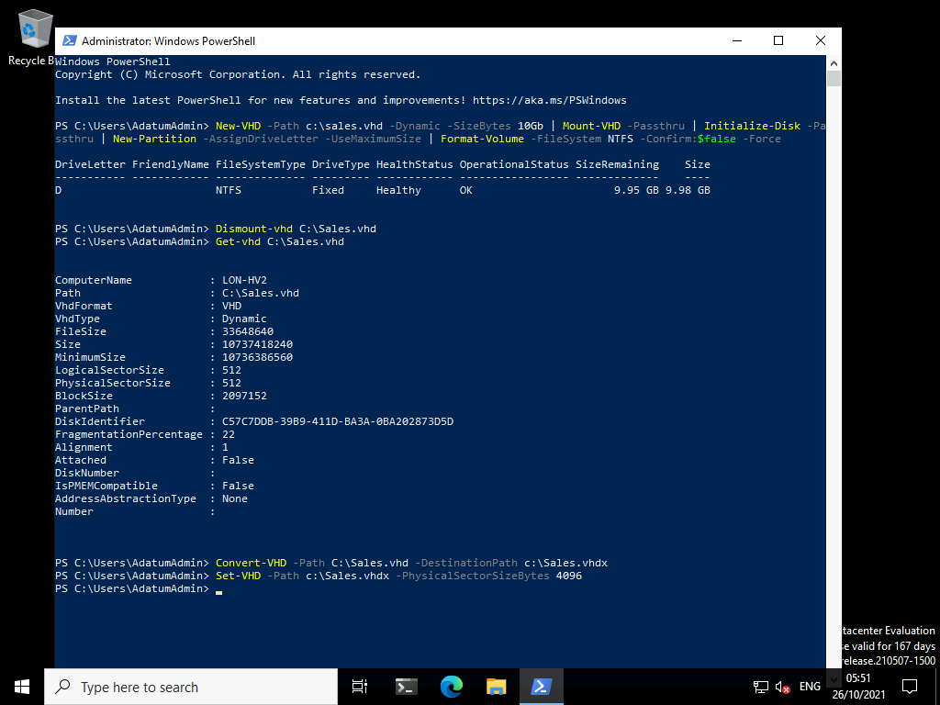

1. To check the properties of the .vhdx file, at the Windows PowerShell command prompt, type the following command, and then press Enter:
2. Get-vhd C:\Sales.vhdx

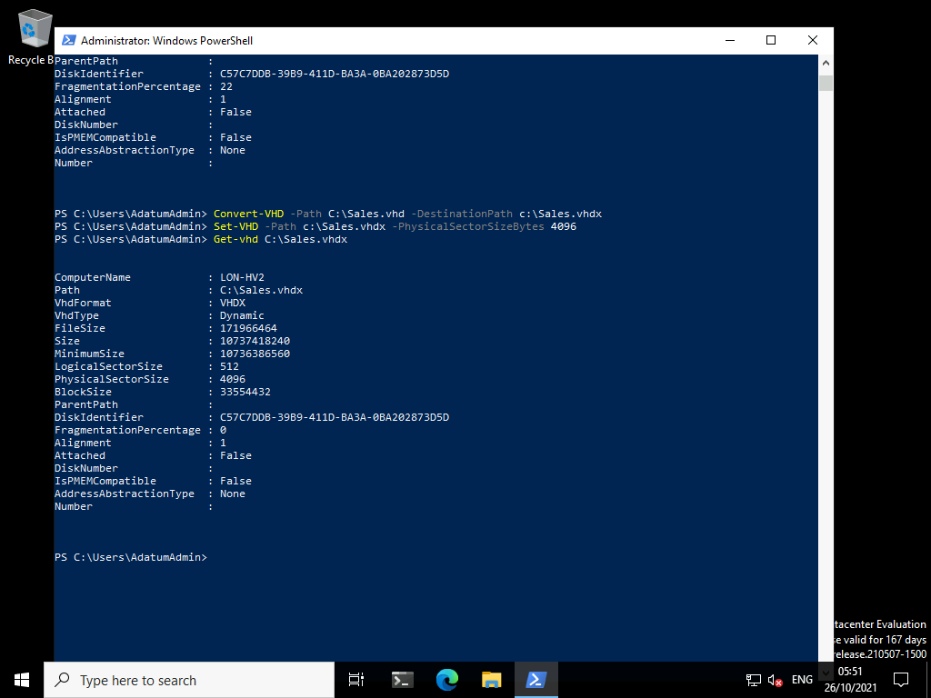

**Question**: What is the physical sector size?

**Answer**: Answers will vary, but it is likely to be 4096.

1. To optimize the .vhdx file, at the Windows PowerShell command prompt, type the following command, and then press Enter:
2. Optimize-VHD -Path c:\Sales.vhdx -Mode Full

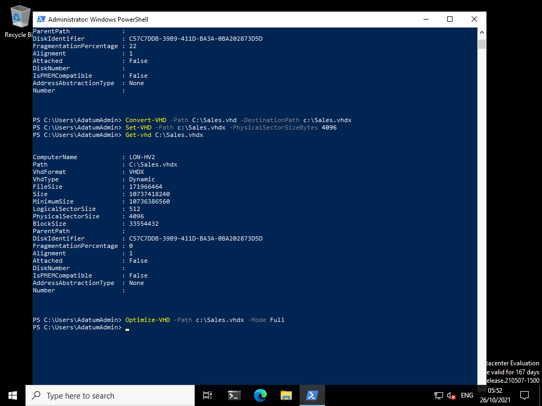

**Results**: After completing this exercise, you should have successfully created and managed virtual hard disks by using Windows PowerShell.

Exercise 4: Creating and managing volumes using the Windows Admin Center

**Scenario**

In the test lab, you start by creating a number of volumes on the installed hard disks.

The main tasks for this exercise are as follows:

1. Create a hard disk volume and format for ReFS.
2. Create a mirrored volume.

Task 1: Create a hard disk volume and format for ReFS

1. Switch to [**LON-MGT1**](urn:gd:lg:a:select-vm) and send the [**CTRL+ALT+DEL**](urn:gd:lg:a:send-vm-key-combo) command and login as **[Adatum\AdatumAdmin](urn:gd:lg:a:send-vm-keys" \o "Paste text into VM)** with the password [**Pa55w.rd**](urn:gd:lg:a:send-vm-keys)
2. Open **Microsoft Edge** and select the **Windows Admin Center** favourite button.

**Note**: The Windows Admin Center (WAC) has been preinstalled in the lab environment. Installing the WAC is a very simple installation process.

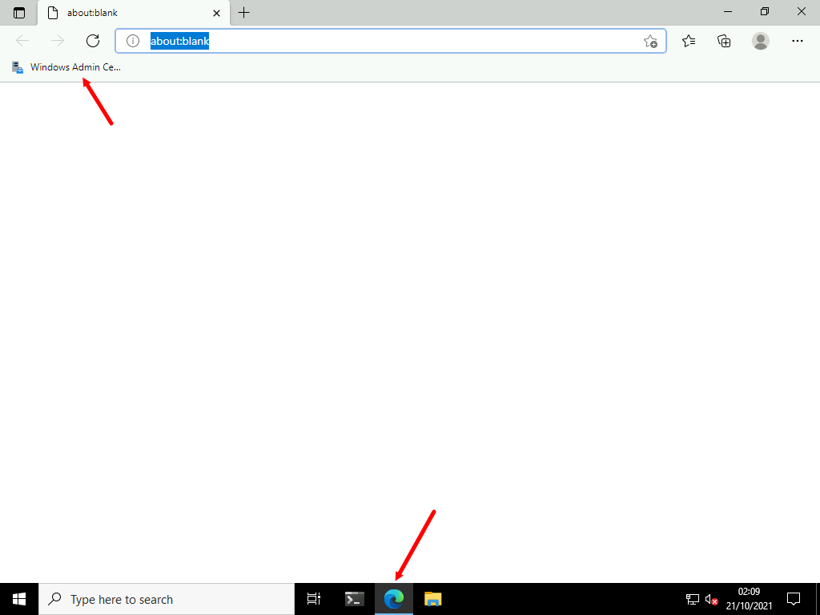

1. On the **All connections** screen select **lon-stor1.adatum.com**.

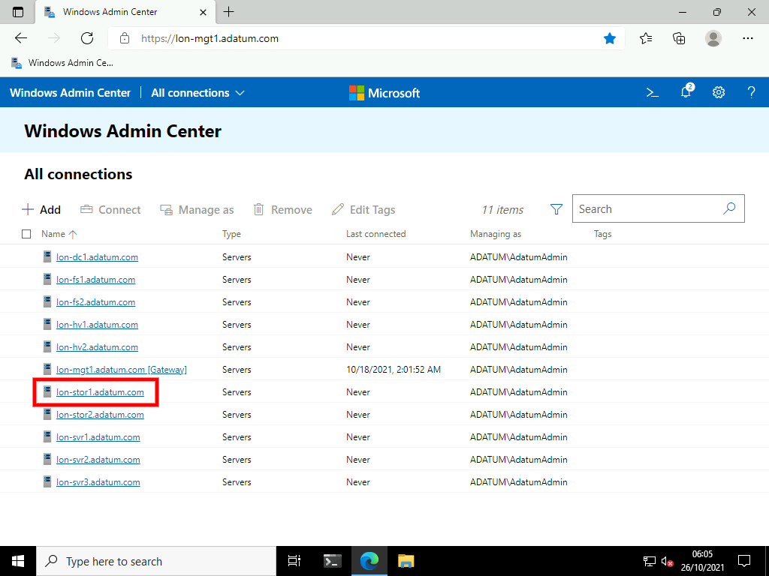

1. On the **Tools** menu scroll down and select **Storage**.

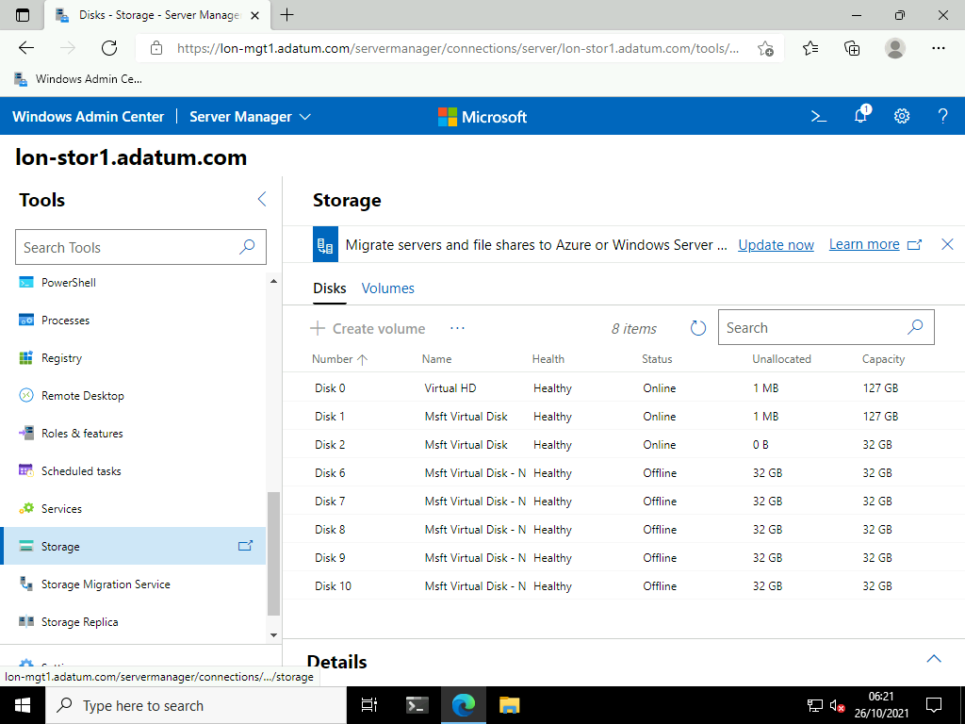

1. Select **Disk 6** and select **Initialize disk**.

**Note**: You may need to click the elipsis (...) button to see the Initialize disk option.

**Note** You may need to update the extension to progress past this point. Select **Update now** in the banner at the top of the screen. You can also select **Settings** then **Extensions**, then scroll to the extension that needs updating. After the update has complete, complete the current step and continue.

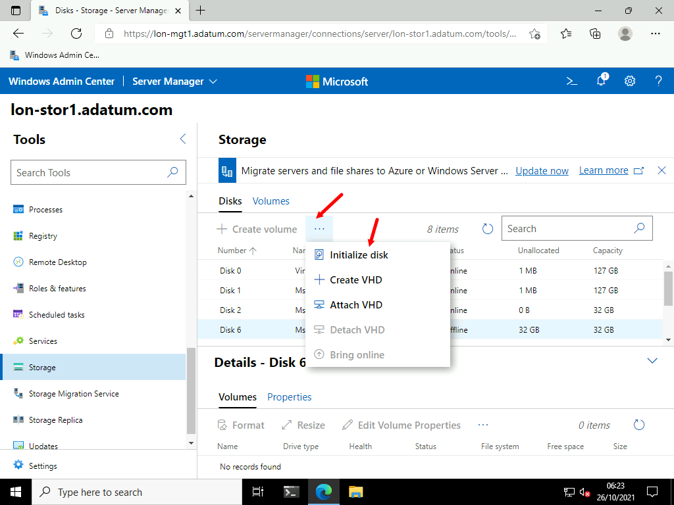

1. On the **Initialize disk** blade leave the partition style as **GPT** and select **Submit**.

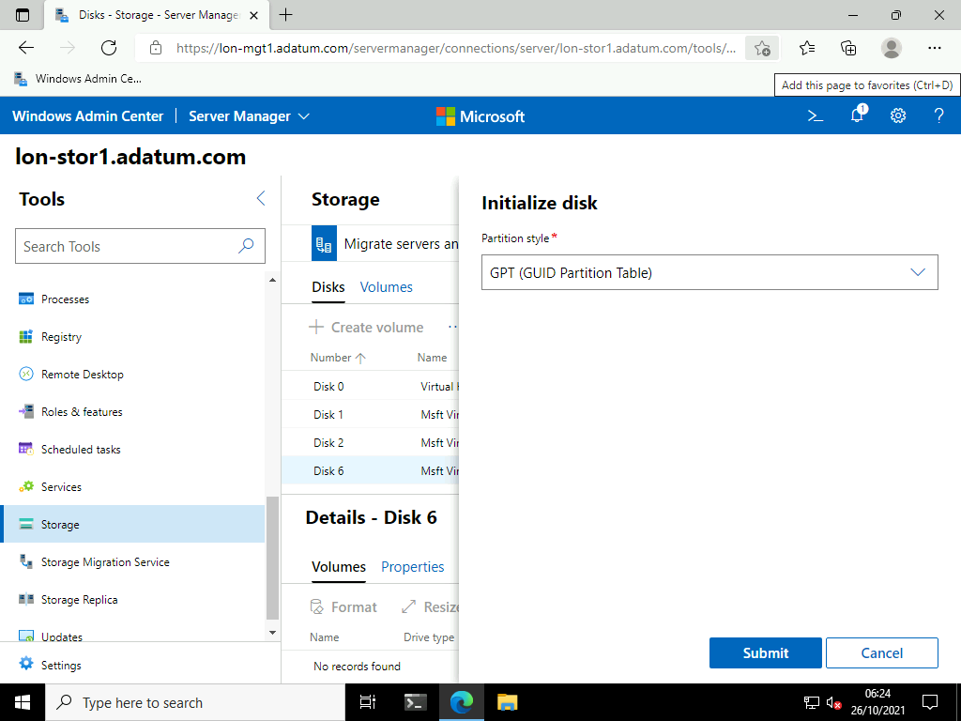

1. The disk should now show online.

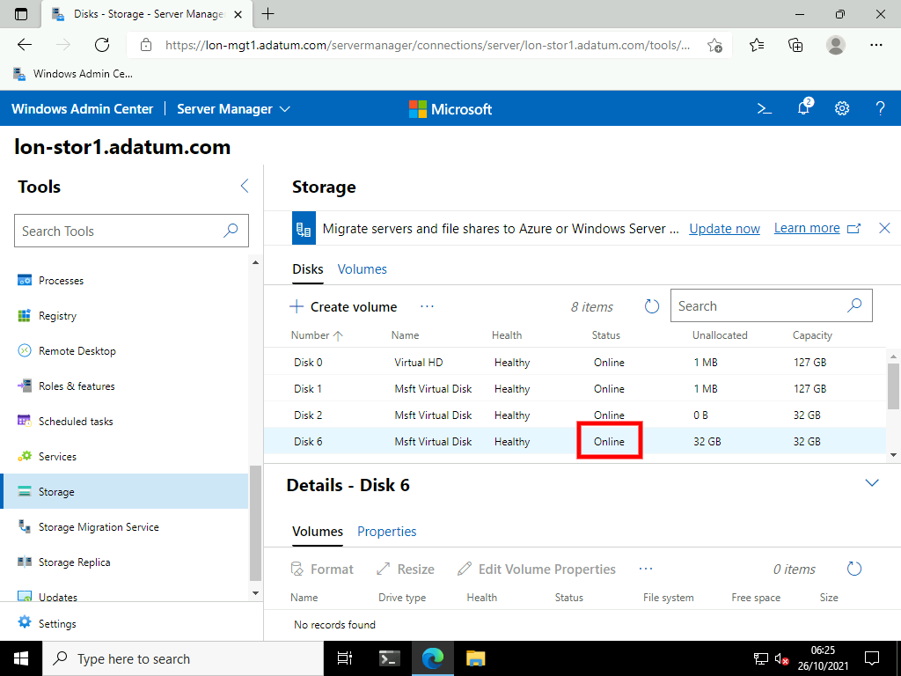

1. Ensure Disk 6 is selected and click **+ Create volume**.

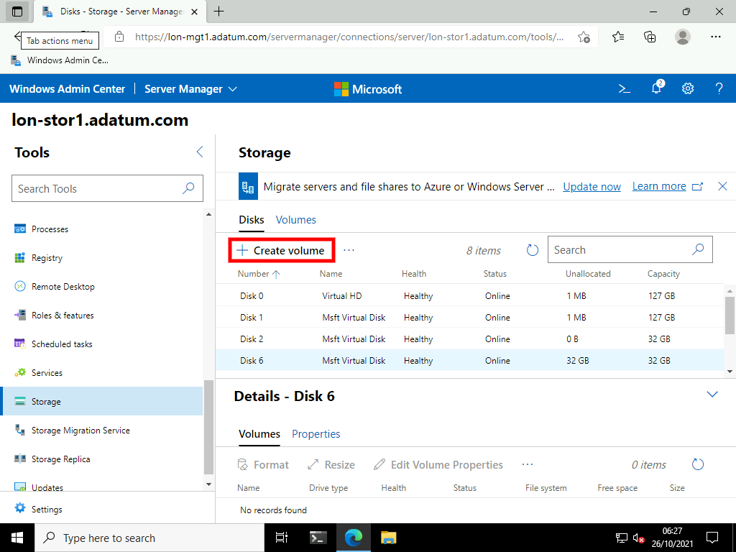

1. On the **Create volume** blade select the following options the click **Submit**.
   * Drive Letter: **W**
   * Volume Label: **[WACVolume](urn:gd:lg:a:send-vm-keys" \o "Paste text into VM)**
   * File system: **REFS**
   * Use maximum size: **Selected**

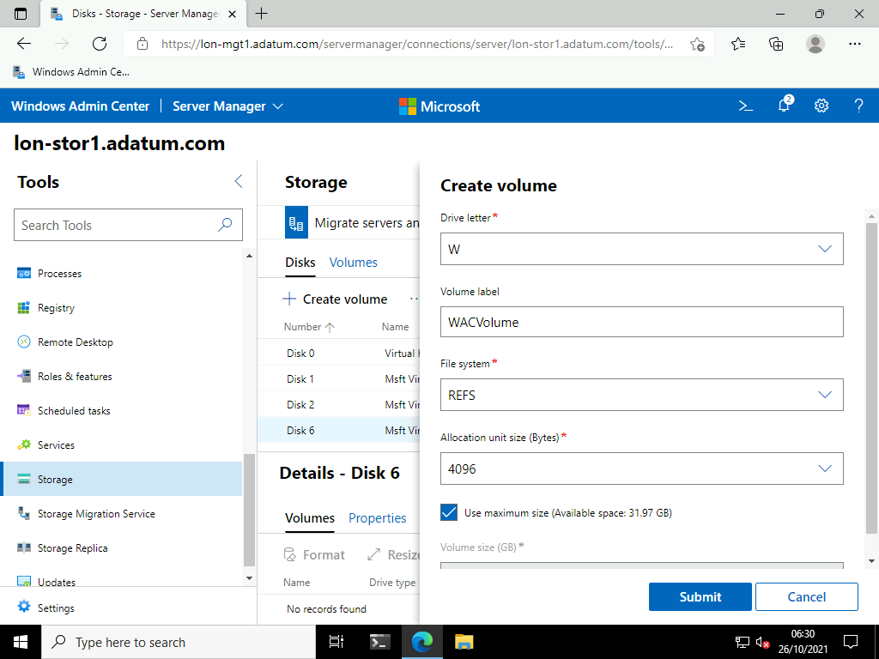

1. Switch to [**LON-STOR1**](urn:gd:lg:a:select-vm) and send the [**CTRL+ALT+DEL**](urn:gd:lg:a:send-vm-key-combo) command and login as **[Adatum\AdatumAdmin](urn:gd:lg:a:send-vm-keys" \o "Paste text into VM)** with the password [**Pa55w.rd**](urn:gd:lg:a:send-vm-keys)
2. On the taskbar, click **File Explorer**.

**Question**: What drive letter has been assigned to the newly created volume?

**Answer**: Drive W as per the screenshot below.

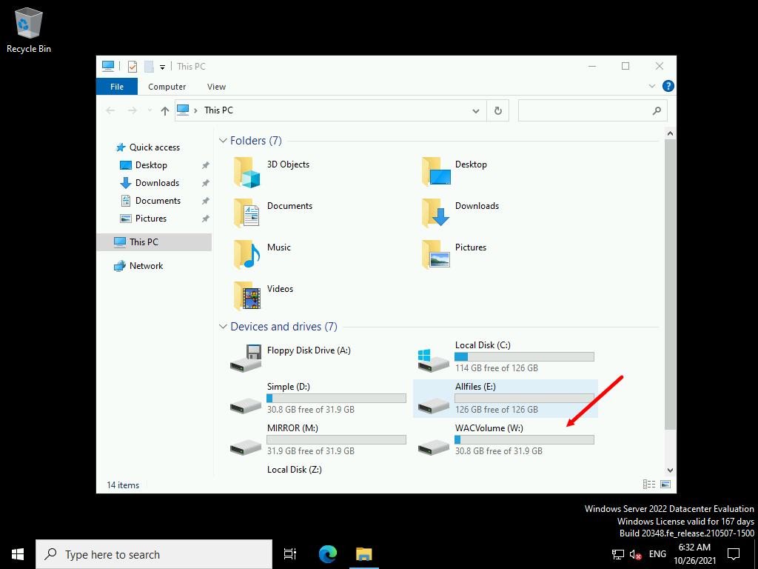

**Results**: After completing this exercise, you should have successfully created several volumes.

Exercise 2: Resizing volumes

**Scenario**

You create a new volume, and then realize that you must resize it. You decide to use the Windows Admin Center to complete this process.

The main tasks for this exercise are as follows:

1. Create a simple volume and resize it.
2. Shrink a volume.

Task 1: Create a simple volume and resize it

1. Switch back to [**LON-MGT1**](urn:gd:lg:a:select-vm). Login as **[Adatum\AdatumAdmin](urn:gd:lg:a:send-vm-keys" \o "Paste text into VM)** with the password [**Pa55w.rd**](urn:gd:lg:a:send-vm-keys) if necessary.
2. Select **Disk 7** and select **Initialize disk**.

**Note**: You may need to click the elipsis (...) button to see the Initialize disk option.

**Note** You may need to update the extension to progress past this point. Select **Update now** in the banner at the top of the screen. You can also select **Settings** then **Extensions**, then scroll to the extension that needs updating and select **Install**. After the update has complete, complete the current step and continue.

1. On the **Initialize disk** blade leave the partition style as **GPT** and select **Submit**.
2. The disk should now show online.
3. Ensure Disk 7 is selected and click **+ Create volume**.



1. On the **Create volume** blade select the following options the click **Submit**.
   * Drive Letter: **S**
   * Volume Label: [**Shrink**](urn:gd:lg:a:send-vm-keys)
   * File system: **REFS**
   * Use maximum size: **Deselected**
   * Volume size (GB): [**10**](urn:gd:lg:a:send-vm-keys)

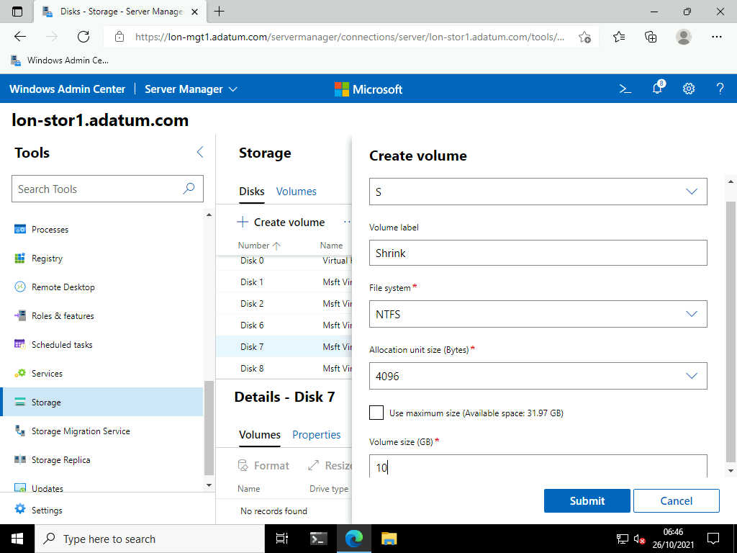

1. In the details pane notice the Volume is available and 10GB in size.

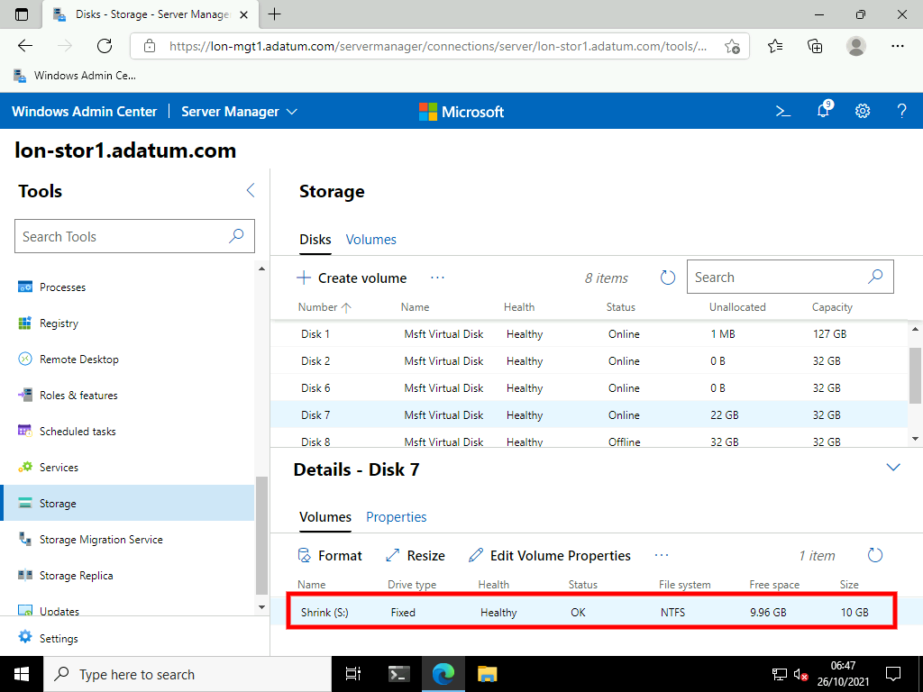

1. Ensure the volume is selected and click **Resize**.

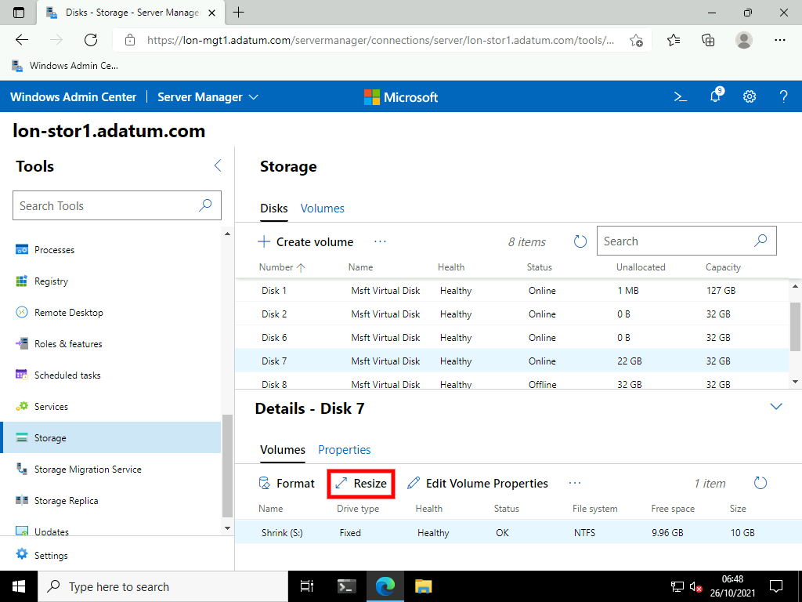

1. On the **Resize volume** blade, in the New volume size (GB) section enter [**20**](urn:gd:lg:a:send-vm-keys) and click **Submit**.

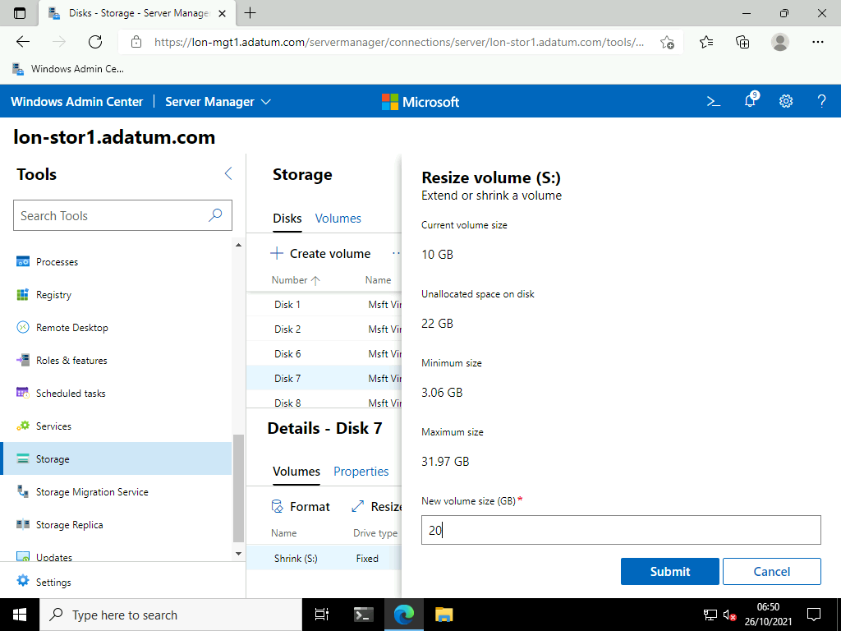

1. In the details pane notice the Volume now **20GB** in size.

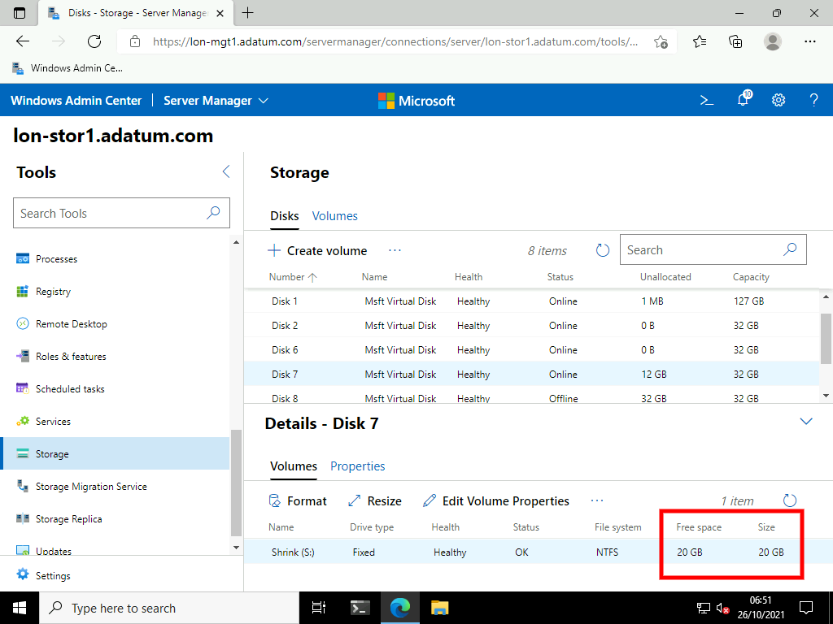

Task 2: Shrink a volume

1. Ensure the volume is selected and click **Resize**.

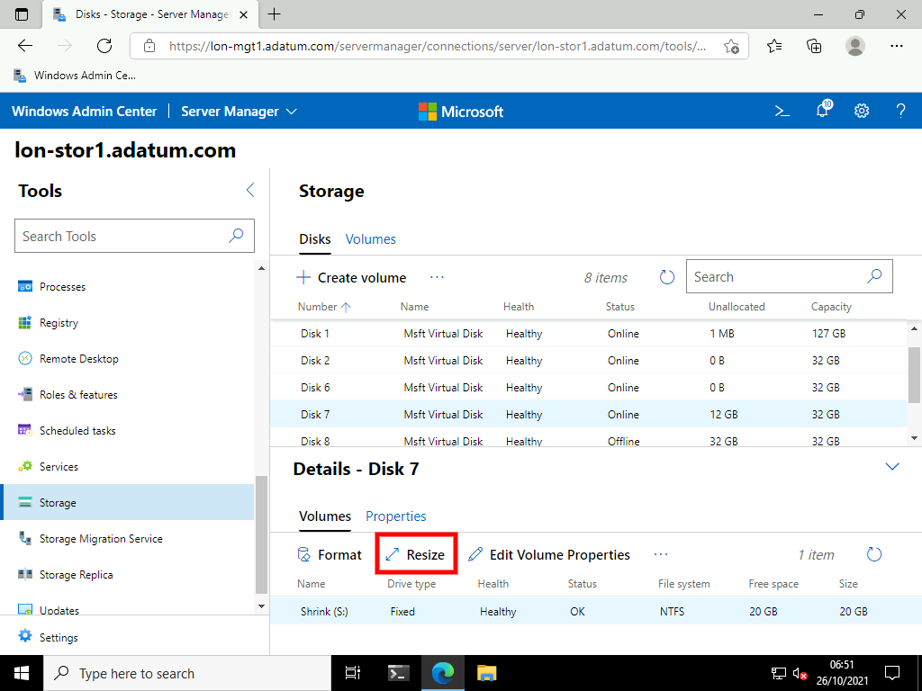

1. On the **Resize volume** blade, in the New volume size (GB) section enter [**5**](urn:gd:lg:a:send-vm-keys).

ReFS drives cannot be shrunk. You will be faced with an error message after entering 5.

**Results** : After completing this exercise, you should have successfully resized a volume using the Windows Admin Center.

Exercise 3: Managing virtual hard disks

**Scenario**

You are required to create and configure virtual hard disks for use in a Windows Server 2016 server computer. The virtual hard disk is for the Sales department. You decide to use Windows PowerShell to achieve these objectives. First, you must install the Windows PowerShell Hyper-V module.

The main tasks for this exercise are as follows:

1. Create a virtual hard disk.
2. Reconfigure the virtual hard disk.

Task 2: Create a virtual hard disk

1. In the Windows Admin Center, return to the **All connections** by clicking the Windows Admin Center title.

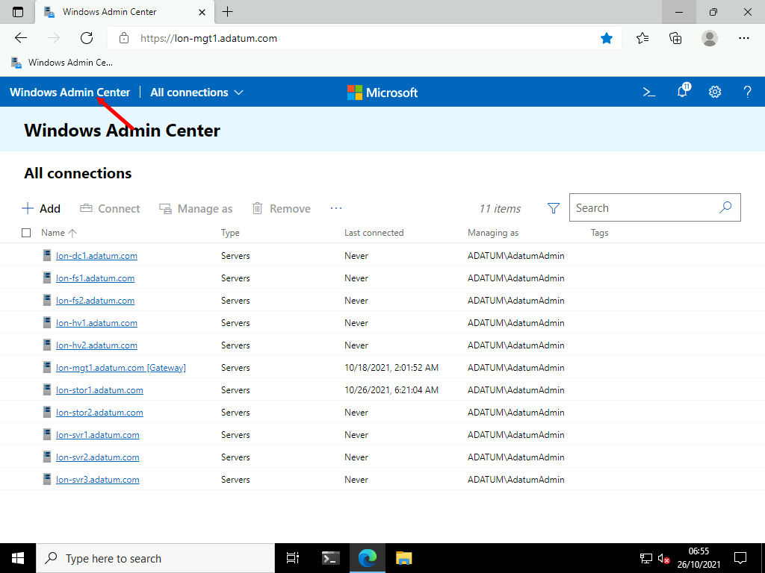

1. Select **lon-hv2.adatum.com**.

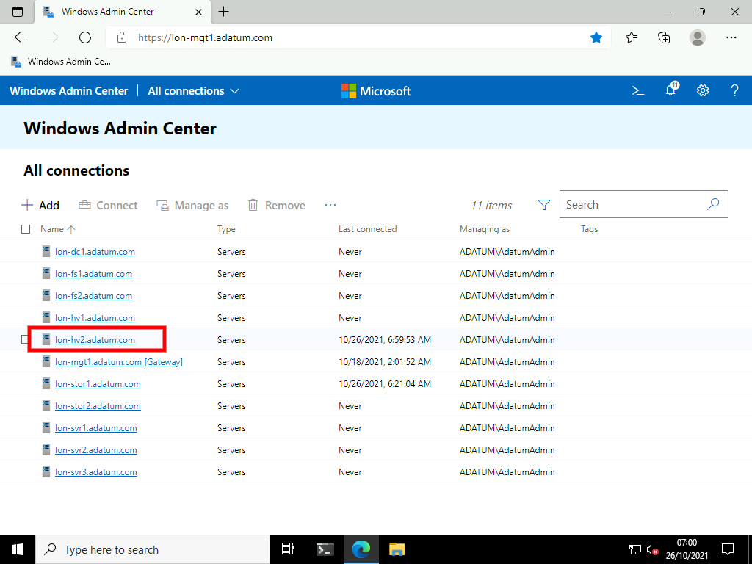

1. On the **Tools** menu scroll down and select **Storage**.

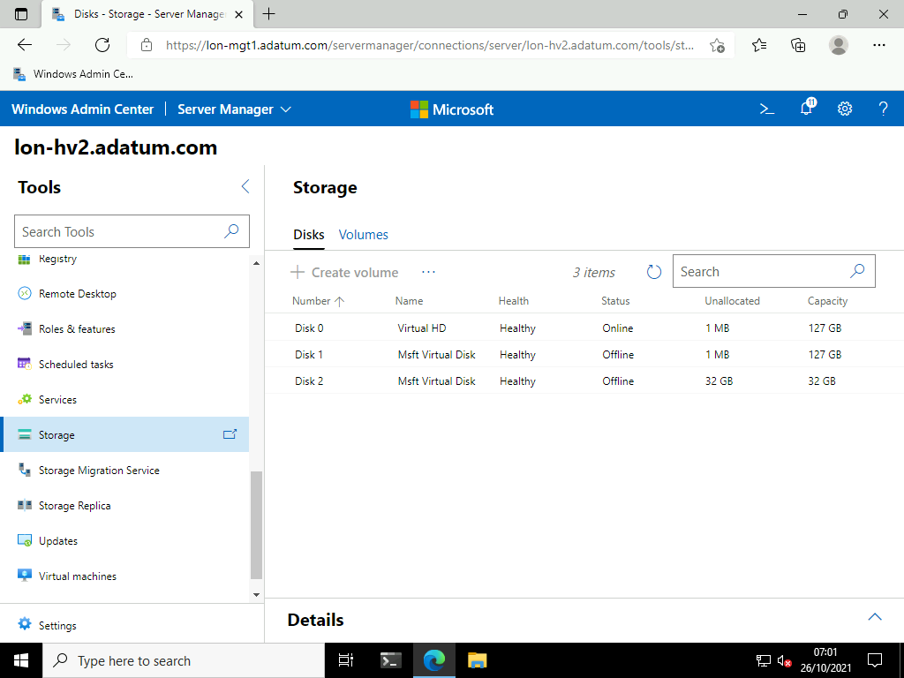

1. Click **+ Create VHD**.

**Note**: You may need to click the elipsis (...) button to see the + Create VHD option.

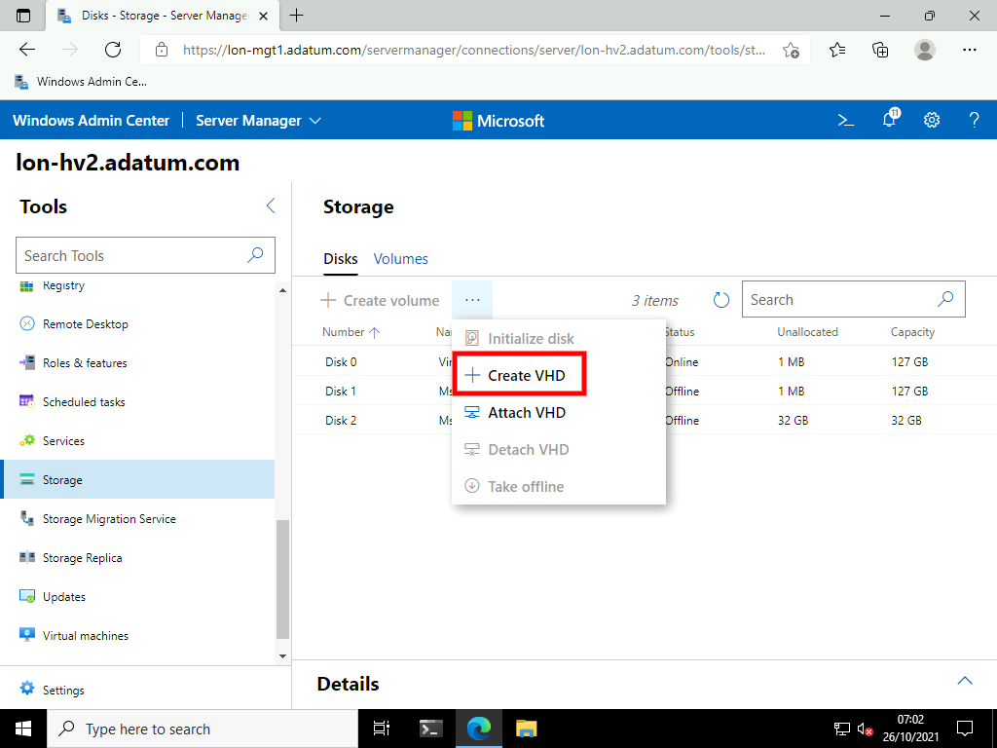

1. On the **Create a vhd** blade select the following options the click **Submit**.
   * VHD folder path: Select **Browse** > Double click C: > Click **OK**
   * New VHD file name: [**sales2**](urn:gd:lg:a:send-vm-keys)
   * File extension: **vhd**
   * Size: [**10**](urn:gd:lg:a:send-vm-keys) GB
   * Virtual hard disk type: **Dynamic**

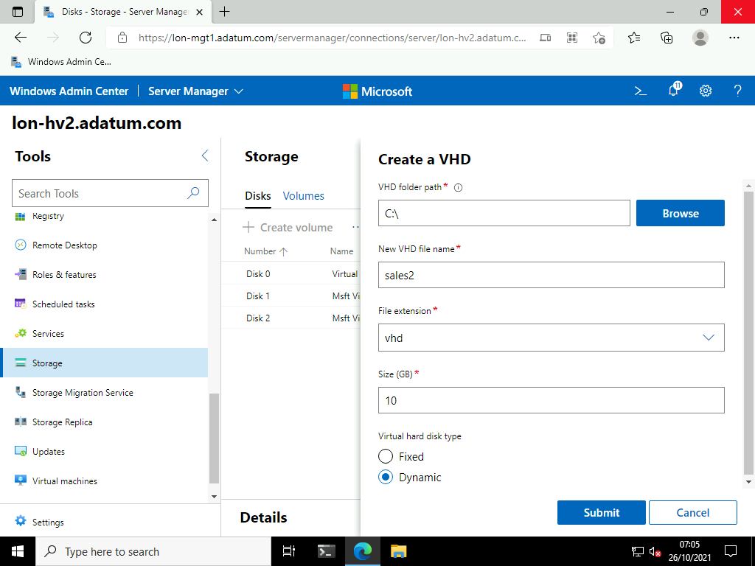

1. Notice the Virtual Hard disk is created and Online.

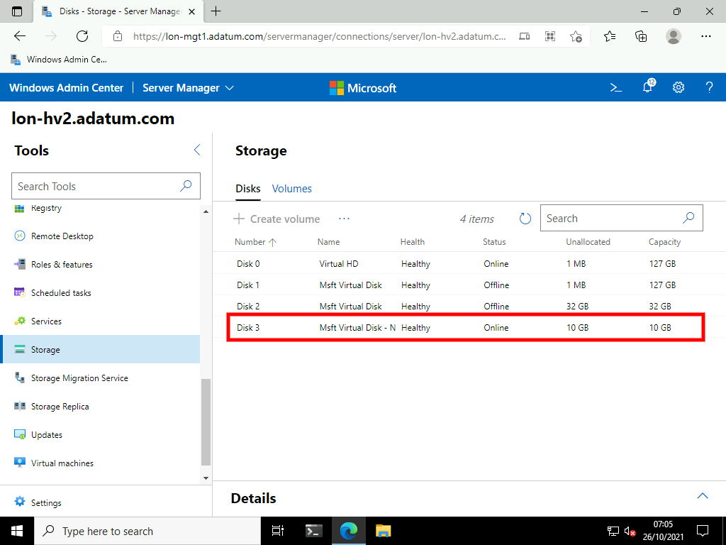

1. Select the disk number that you created, then select **Initialize Disk**.

**Note**: You may need to click the elipsis (...) button to see the Attach VHD option.

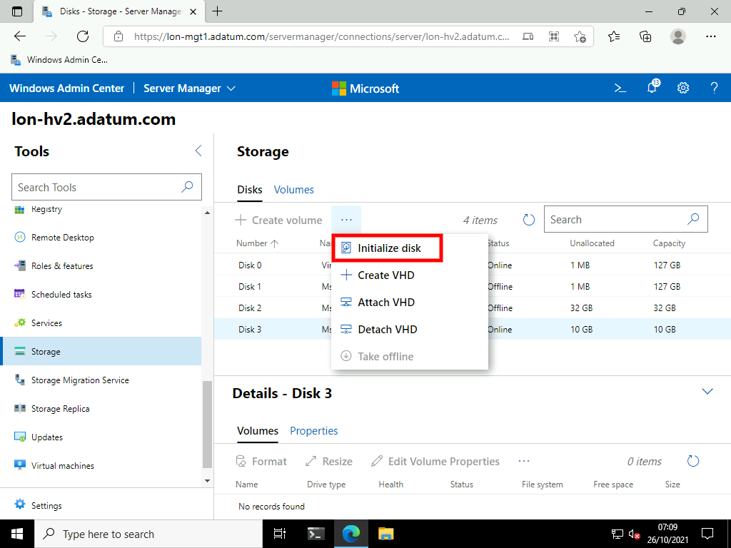

1. On the Initialize disk blade click **Submit**.

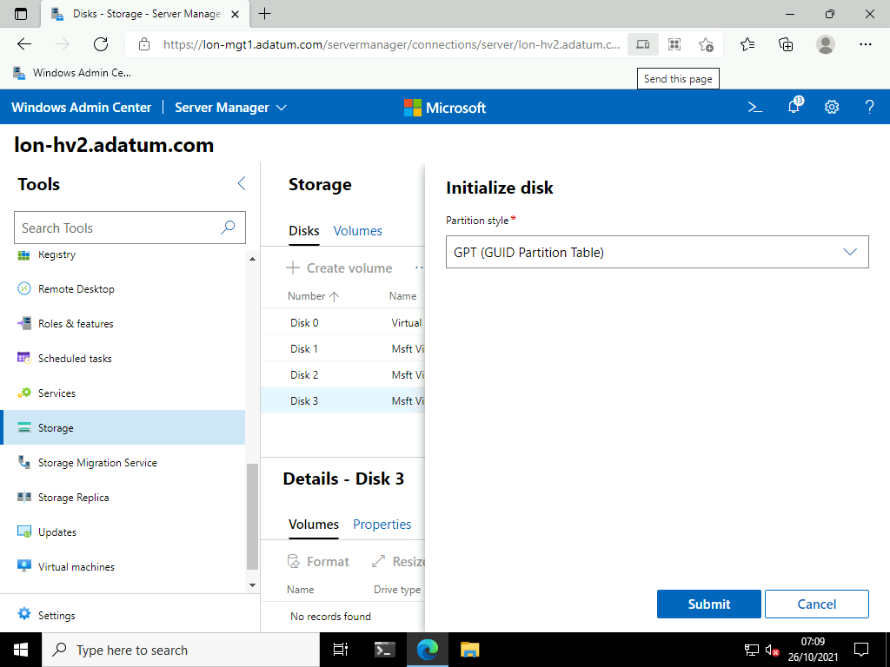

1. Select the disk number you created, then select **Create Volume**.

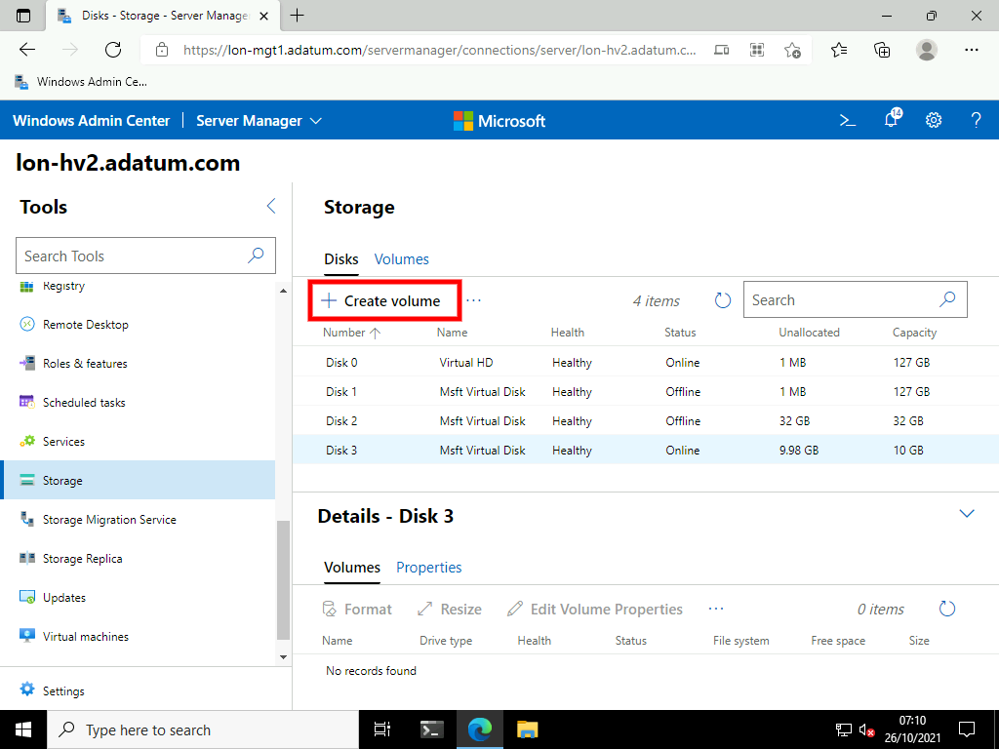

1. On the **Create volume** blade select the following options the click **Submit**.
   * Drive Letter: **Y**
   * Volume Label: [**WACVHD**](urn:gd:lg:a:send-vm-keys)
   * File system: **REFS**
   * Use maximum size: **Selected**

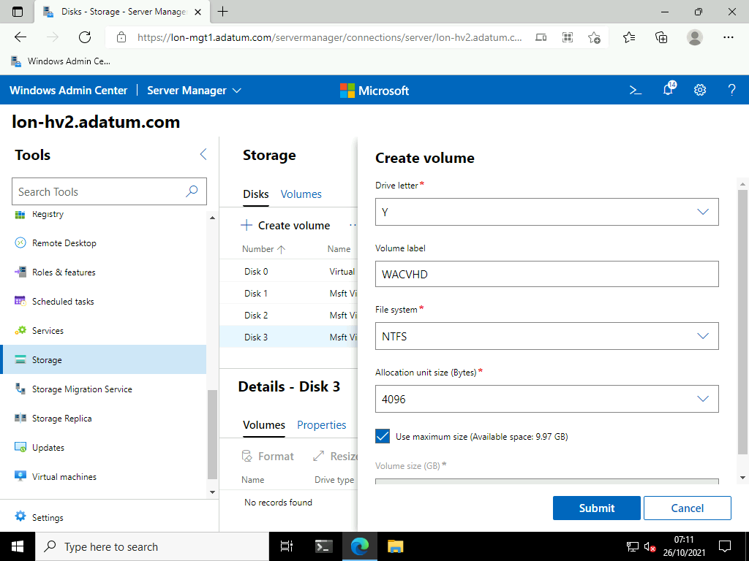

1. To dismount the virtual hard disk, select the disk number you created and select **Detach VHD**.

**Note**: You may need to click the elipsis (...) button to see the Detach VHD option.

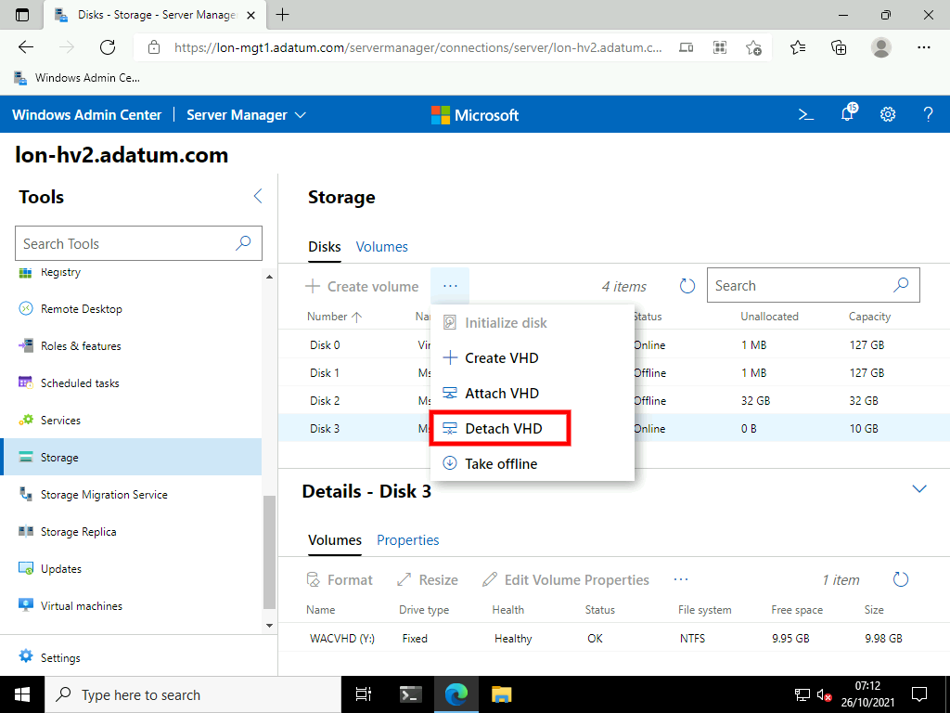

1. Notice the Disk is no longer available (mounted) in the Windows Admin Center. The disk has not been deleted, instead it has been detatched.

**Results**: After completing this exercise, you should have successfully created and managed virtual hard disks by using Windows Admin Center.

**Congratulations!** You have now completed this lab. To continue to the next lab click End Lab in the Tools Menu . If you wish to contiue with this lab at a later date ensure you save the lab environment rather than ending it.